BBC: Are the Band Aid lyrics really that controversial?
By Sophie Miller, Newsbeat reporter
24 Nov 2014

It seems the lyrics for Band Aid 30's Do They Know It's Christmas have caused some controversy.
Singers, charities, newspaper editorials and some Twitter users have criticised the charity single calling it "patronising" and "detrimental to Africa".

But the lyrics they quote aren't always the ones that appear in the final song, which apparently went through quite a few changes during the recording.
On 15 November at the recording of the single reporters were handed a sheet of the lyrics, updated 30 years on to reflect the current Ebola crisis in west Africa.
Blogs, Twitter and news agencies have been giving their verdict.

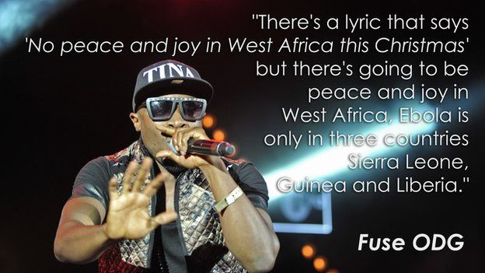
So why is everyone getting upset about the fourth outing of a charity song that has raised millions in the past? One major criticism is the whole sentiment of the song, Do They Know It's Christmas?, which was taken from the original recording 30 years ago and helped famine-stricken Ethiopians. The Washington Post says that according to a recent survey, 87% of the population in Liberia is Christian, so of course they know it's Christmas.
Many commentators, including American Al Jazeera, accuse the song of having a "them and us" feel about it. It claims the song portrays the fantasy of an Africa filled with victims waiting to be saved.

Robtel Pailey is from Liberia and is studying at the School of Oriental and African Studies in London. She has been telling the BBC that the song is "patronising, redundant and unoriginal" and that it "reeks of the white saviour complex because it negates local efforts that have come before it".
She's referring to the song Africa Stop Ebola which was produced by Malian, Ivorian, Congolese, and Guinean musicians. Carlos Chirinos, the producer of that song has spoken out about the Band Aid single, saying: "It's worth doing it for the money and the money is needed.
"However, it comes at a cost and the cost is the way in which Africa is being portrayed to the rest of the world."

Fuse ODG told Newsbeat he didn't want to be involved because he "felt it wasn't in line with the new African movement".
He said: "There's a lyric that says, 'No peace and joy in West Africa this Christmas' but there's going to be peace and joy in west Africa.
"Ebola is only in three countries: Sierra Leone, Guinea and Liberia." In fact the lyric that made it to the final edit is, "Bring peace and joy this Christmas to West Africa", an echo of traditional cards and carols in many parts of the world.
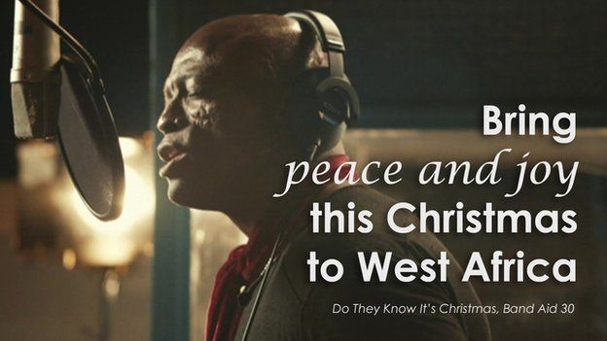
Bob Geldof told Newsbeat he had a phone call with Fuse ODG and offered him the option of changing the lyrics.
"If there's a line you can't sing, change it and he said he just felt awkward."
Fuse says he responded: "This song has so many lines. I can't just change one line and then think the song is OK. I didn't agree with most of the lines in the song." Emeli Sande also sang on the single.
On the day of recording (before she had recorded her lines), Newsbeat asked her what she thought of the updated version of the song.
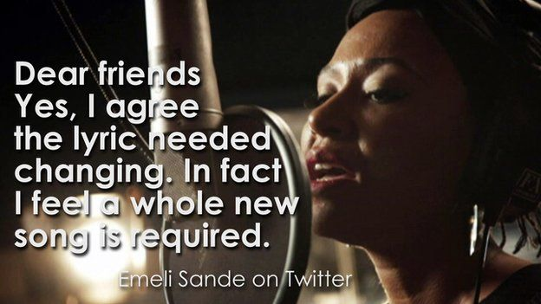
"I think it's really beautiful and really poignant," she said. "It really brought home that people are dying but on top of that they can't comfort one another."

But since then she has released a statement saying she feels "a whole new song is required".
The singer went on to say that she and African singer Angelique Kidjo "made and sang our own edits" but added: "Unfortunately, none of these made the final cut."
The single went straight to number one this week after shifting 312,000 copies and making it this year's fastest-selling single, but Bob Geldof has asked people to delete it and download it again.
There is some support for it however.
A blog by the Independent's Benjamin Parker is called "Band Aid 30: Leave Bob Geldof's Christmas anthem alone — how much have you raised for Ebola?"

The writer goes on to say: "Academic types are acting like the lyrics are worth line-by-line theorems, while social media comments are outraged over the choice of celebs singing it."
The reporter is keen to point out the good intentions behind the release.
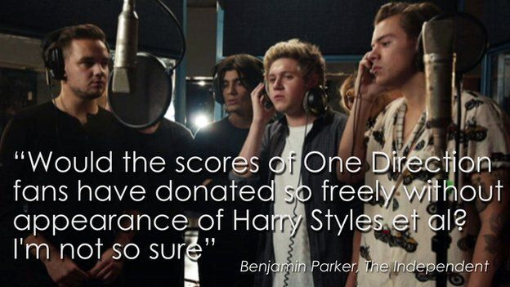
"Would the scores of One Direction fans have donated so freely without appearance of Harry Styles et al? I'm not so sure."
And he sticks up for the lyrics.
"The West's desire to fight Ebola - whether acted upon or simply lip service at this time - is nothing to do with the relics of empire."

