Code Breakers & Code Makers Name: Hr:

1. What do you think this code says? Work it out in the space below. You have 5 mins! (Clues: it is not an anagram, and there are two words with a space in between.)

SRHGLIB ILXPH!

This kind of cipher is called what? _______________________________

See page 6 for this information and answer - Source: http://rumkin.com/tools/cipher/

During WWII, secret codes were essential to all sides, in order to obscure messages about troop movements, locations, and future plans. Many different codes were used. Today, you’re going to study just two particular cases: the “code breakers,” or the cryptographers (a.k.a. constructing and analyzing secret codes) at Bletchley Park, and the “code makers,” or the Navajo Code Talkers.

Assignment

Congratulations! You are a graphic design student who has been chosen to research and design a memorial for World War II cryptography. You are being paid to investigate two different cryptography topics, then you get to recommend a memorial for one topic.
Your first objective during this lesson is to write a series of memos explaining each of the two code topics to the Board of Directors of the WWII Memorial Fund. Your second objective is to design one memorial for either code topic, your choice. You may listen to music while you design your memorial, but not before. If you take out your phone before you’re ready for the memorial, your phone will be confiscated.
There is a series of class documents (so don’t write on them) that have information you’ll need for each code topic. You will find them in the front of the room in folders marked “Secret Code Files.” If you’re doing this at home, links to these documents are on page 5.
You are graded according to quality of completion. This is worth 30 assignment points.

BLETCHLEY PARK Please write in complete sentences.

Major players involved:

How did Alan Turing die?
How does the Enigma code work?

How did Bletchley Park begin working to crack Enigma?

How did Bletchley Park affect the outcome of WWII?

In the space below, compose a short memo to the Board of Directors informing them of your research, so they are aware of what Bletchley Park was and why it is significant to remember when studying WWII.

Memorandum from the desk of ____________________ Date: ___ March 2015
To the Board of Directors,

Sincerely, _________________
NAVAJO CODE TALKERS Please write in complete sentences.
Major players involved:

When were the Navajo Code Talkers organized, according to the memo on the first page of the research packet? Why was Navajo selected to be used?

How did the Navajo Code Talkers’ system work?

How did the Navajo Code Talkers affect the outcome of the war?

In the space below, compose a short memo to the Board of Directors informing them of your research, so they are aware of who the Navajo Code Talkers were and why they are significant to remember when studying WWII.
Memorandum from the desk of ____________________ Date: ___ March 2015

To the Board of Directors,

Sincerely, _________________

MEMORIAL DESIGN Please write in complete sentences.

Now that you have researched the Navajo Code Talkers and Bletchley Park and written two memos about their wartime service and impact, choose one of the code topics to commemorate with a memorial. Sketch it in pencil or pen below.
Your memorial should be symbolic in nature and include a two-sentence inscription that explains the memorial in a simple and solemn way. Your memorial can be a statue, sculpture, building, walkway, garden, pond, or any other structure/location of your choice.
For inspiration (if completing on laptop), scroll to pages 7-14 to see examples of memorials around the world. (The Holocaust Memorial in Paris is particularly eerie and memorable.)

Close with one short paragraph (3-4 sentences) that explains how your memorial symbolizes the accomplishments, sacrifices, or “story” of the group you chose to honor.

SOURCES:
http://www.bbc.co.uk/history/people/alan_turing
http://www.bbc.co.uk/history/topics/enigma
http://www.history.com/news/world-war-ii-memo-cracked-by-allies-found
http://www.bbc.co.uk/history/worldwars/wwtwo/enigma_01.shtml
http://www.history.co.uk/history-of-ww2/code-breaking
http://www.bbc.co.uk/news/magazine-12266109?print=true
http://www.texancultures.com/assets/1/15/Teaching%20with%20Primary%20Sources-%20Native%20Words,%20Native%20Warriors.pdf
http://www.archives.gov/education/lessons/code-talkers/images/letter-01.jpg
http://www.archives.gov/education/lessons/code-talkers/images/letter-02.jpg

ATBASH CIPHER

The Atbash cipher is a very common, simple cipher. It was for the Hebrew alphabet, but modified here to work with the English alphabet. Basically, when encoded, an "A" becomes a "Z", "B" turns into "Y", etc.

The code above thus says “History rocks!”

Source: http://rumkin.com/tools/cipher/atbash.php
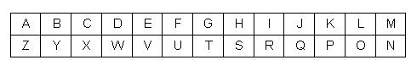

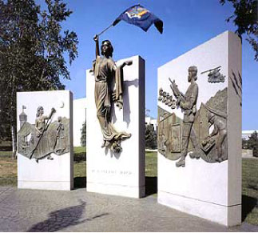
NEW YORK STATE WOMEN VETERANS MEMORIAL

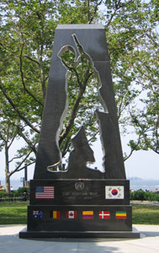
New York Korean War Veterans Memorial

“…this series of stone pillars in Anthem, Arizona, [is] calibrated to achieve maximum emotional and visual impact — the sun only highlights the Great Seal of the United States at 11:11 a.m. local time on Nov. 11 — on Veterans Day. For those who don't remember history class, that was the day the armistice bringing World War I to a close was signed.”
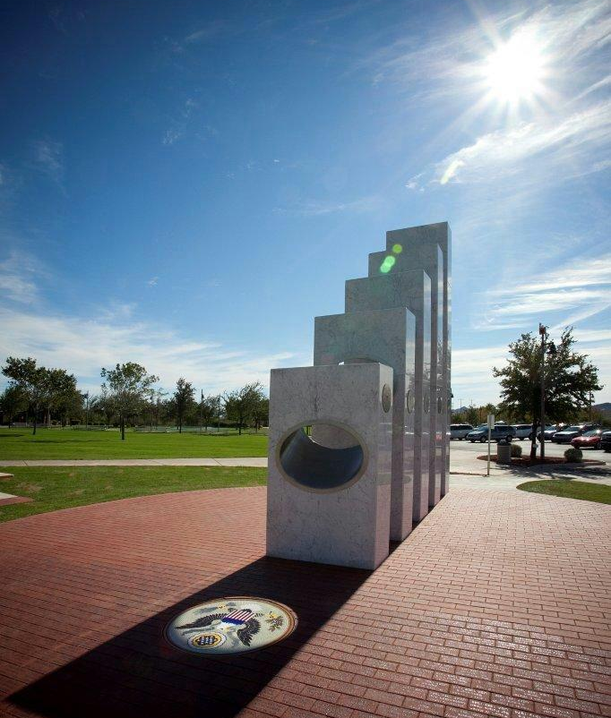

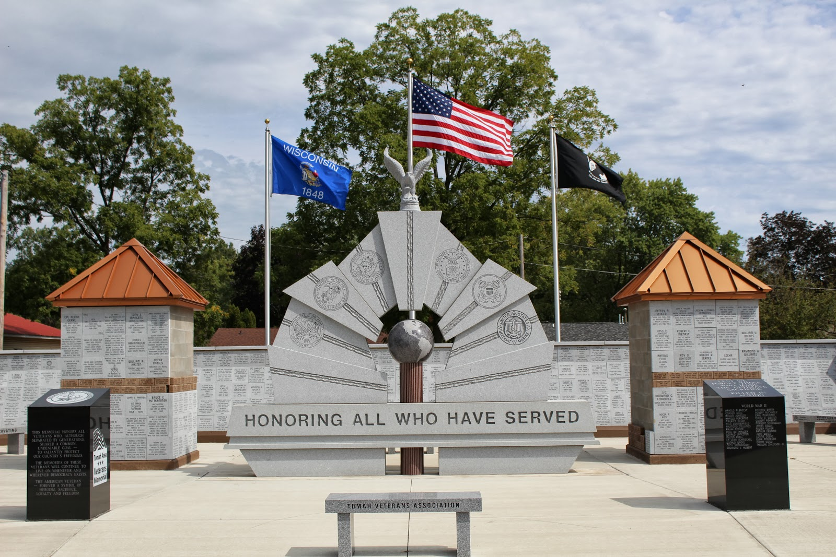
VETERANS MEMORAL IN WISCONSIN

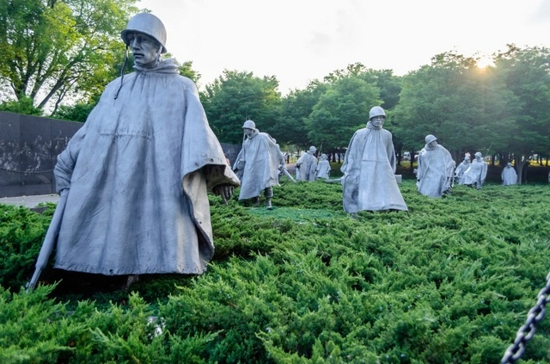
KOREAN VETERANS MEMORIAL IN WASHINGTON, D.C.

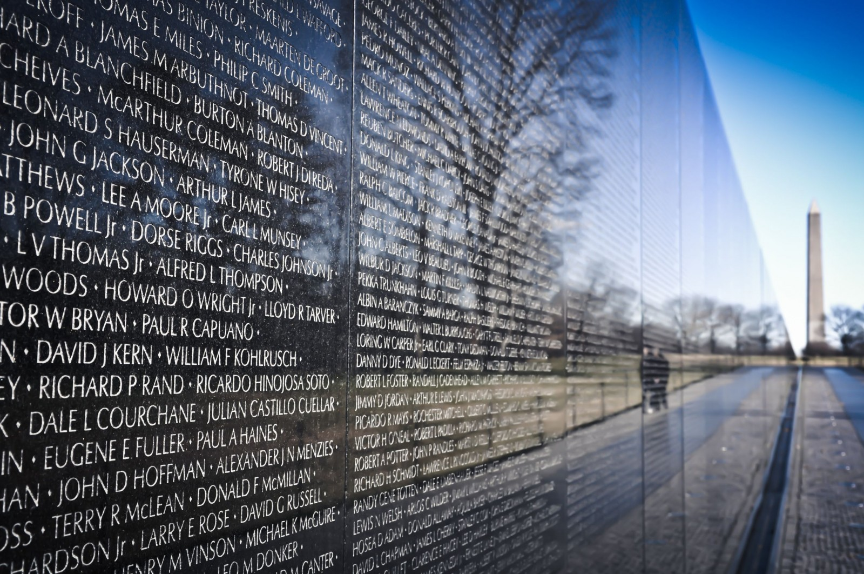
VIETNAM WAR MEMORIAL IN WASHINGTON, D.C.

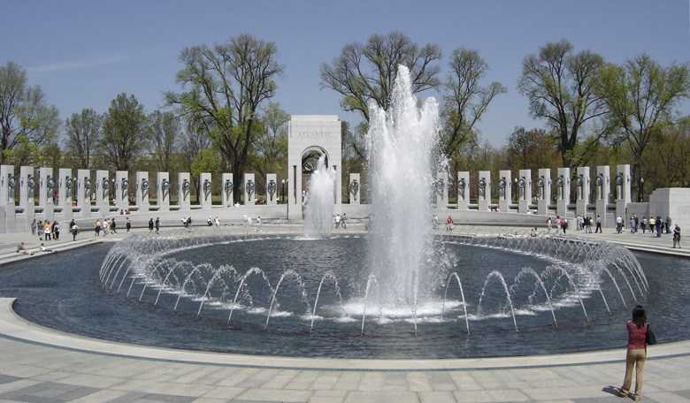
WORLD WAR II MEMORIAL IN WASHINGTON, D.C.

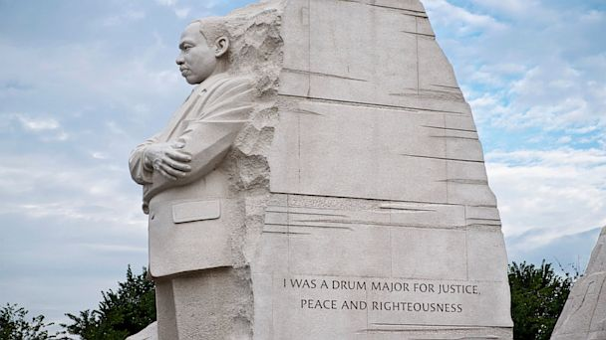
MARTIN LUTHER KING, JR., MEMORIAL

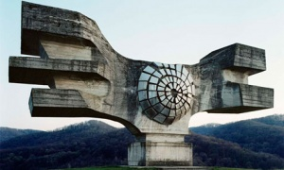
CROATIAN WORLD WAR II MONUMENT

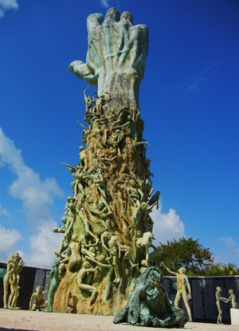
HOLOCAUST MEMORIAL

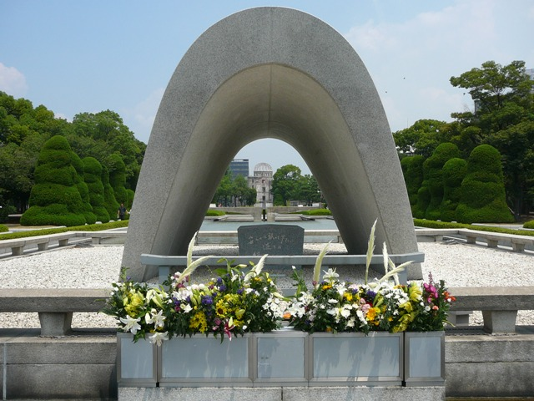
HIROSHIMA PEACE MEMORIAL

MORE FROM THE HOLOCAUST MEMORIAL:
