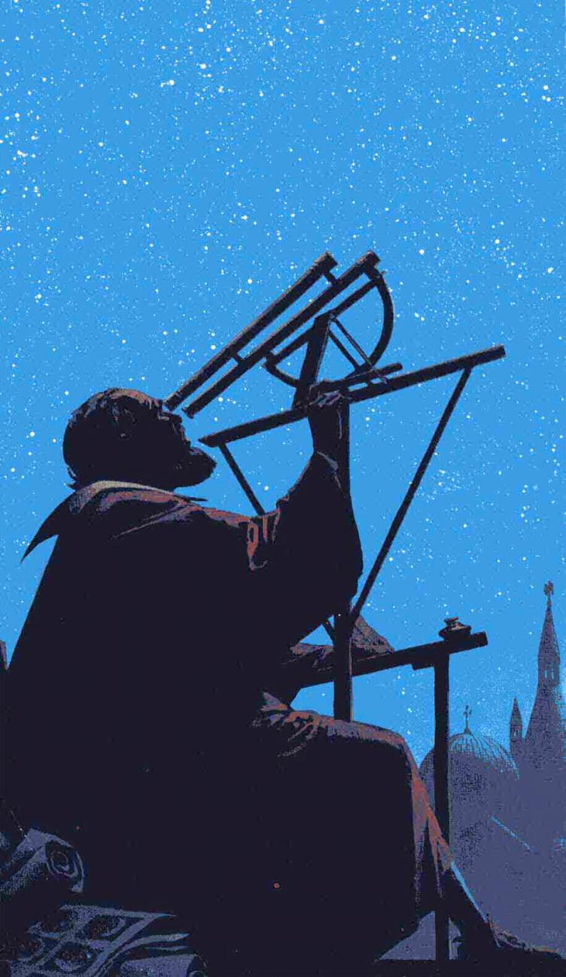
By Dava Sobel

Galileo's Place in Science

Posted 10.29.02
NOVA

The drama of Galileo's trial by the Inquisition in 1633 has cast him as a renegade astronomer who scoffed at the Bible and drew fire from a Church blind to reason. Indeed, the myth of the martyred Galileo perfectly symbolizes the current division between science and faith. But the real Galileo, never tortured or excommunicated, remained a loyal Catholic throughout his life.
Galileo pursued all his bold investigations convinced that Nature followed a Divine order. Just as the Bible represented the dictated word of God, so the natural world embodied God's work. The persistent observer could decipher its hidden patterns, on Earth and in the heavens.

The language of math
By his own reckoning, Galileo's most important contribution involved neither the astronomical discoveries that immortalized his name, nor his published defense of Copernicus, but rather his application of mathematics to the study of motion.
Earlier philosophers, beginning with Aristotle, had concerned themselves with pinning down the causes of motion. Galileo dropped all Aristotelian talk of why things moved and focused instead on the how, through painstaking observations and measurements. Instead of "essences" and "natural places," Galileo sought quantifiable entities such as time, distance, and acceleration to describe the way everyday objects move, bend, break, and fall. His emphasis on the practical application and value of science set him apart from most philosophers of his time.
Galileo correctly envisioned the experimental, mathematical analysis of Nature as the wave of the future
"Philosophy is written in this grand book the universe," Galileo said. "But the book cannot be understood unless one first learns to comprehend the language and to read the alphabet in which it is composed. It is written in the language of mathematics, and its characters are triangles, circles, and other geometric figures, without which it is humanly impossible to understand a single word of it."

Measuring motion
Galileo probably gained his introduction to experimental technique while assisting his musician father, who conducted home experiments in the physics of sound. Galileo began his own experimental studies of motion while serving as a young mathematics professor at Pisa, where he is said to have dropped cannonballs from the Leaning Tower to demonstrate how objects of different weights fall with the same speed [see Falling Objects]. He continued his experiments during nearly two decades of teaching at the University of Padua, near Venice, where he measured the swinging of pendulums until he could describe their periods by a mathematical law, and he rolled bronze balls down inclined planes a thousand ways to derive the rate of acceleration in free fall.
Through such pursuits, Galileo discovered and described phenomena that generations of philosophers had not even noticed. For example, the shape of the path traced through space by a hurled or fired missile, Galileo showed, was not just "a line somehow curved," as his predecessors had said, but always precisely a parabola. And when lemons dropped from treetops, or cannonballs from towers, each one picked up speed in the same characteristic pattern, tied to the elapsed time of its fall: Whatever distance the object covered in one instant—measured as a pulse beat, a sung note, the weight of water that dripped from Galileo's timing device—by the end of two such instants it would travel four times as far. After three instants, it wound up at nine times the initial distance of descent; after four instants, 16 distance units—and so on, always accelerating, always covering a distance determined by the square of the time passed [see Inclined Plane].
Posterity agrees that Galileo's great genius lay in his ability to observe the world at hand
Galileo uncovered this fundamental relationship between distance and time without so much as a reliable unit of measure or an accurate clock. Italy possessed no national standards in the 17th century, leaving distances open to guesstimate gauged by flea's eyes, hairbreadths, lentil or millet seed diameters, hand spans, arm lengths, and the like. Galileo perforce delineated his own arbitrary units along the length of his experimental apparatus. As long as these units matched one another, he reasoned, he could use them to discern mathematical relationships. Lacking any kind of precision timekeeper, Galileo literally weighed the moments of his experiments: He allowed water to drip through a narrow pipe during the interval of interest; then he balanced the collected water's weight against grains of sand.

"...a large and excellent science"
Aristotelian philosophers of Galileo's day railed at such a mathematical approach to physics, on the grounds that mathematicians pondered immaterial concepts, while Nature consisted entirely of matter. They looked down on mathematicians and denigrated the study of mathematics as inferior—even irrelevant—to natural philosophy. Nature, in their view, could not be expected to follow precise numerical rules.
But Galileo correctly envisioned the experimental, mathematical analysis of Nature as the wave of the future: "There will be opened a gateway and a road to a large and excellent science," he predicted, "into which minds more piercing than mine shall penetrate to recesses still deeper." Among the first to bear out this prophecy was Sir Isaac Newton, born within a year of Galileo's death, who codified mathematical laws of motion and universal gravitation.
Posterity agrees that Galileo's great genius lay in his ability to observe the world at hand, to understand the behavior of its parts, and to describe these in terms of mathematical proportions. For these achievements, Albert Einstein dubbed Galileo "the father of modern physics—indeed of modern science altogether."

This feature originally appeared on the site for the NOVA program Galileo's Battle for the Heavens.
After reading the article above, please compose a summary paragraph below (5 of your best sentences including a topic sentence, supporting details, and closing sentence) explaining why Galileo could be considered the “Father of Modern Science.”
____________________________________________________________________________________________________________________________________________________________________________________________________________________________________________________________________________________________________________________________________________________________________________________________________________________________________________________________________________________________________________________________________________________________________________________________________________________________________________________________________________________________________________________________________________________________________________________________________________________________________________________________________________________________________________________________________________________________________________________________________________________________________________________________________________________________________________________________________________________________________________________________________________________________________________________________________________________________________________________________________________________________________________________________________________________________________

