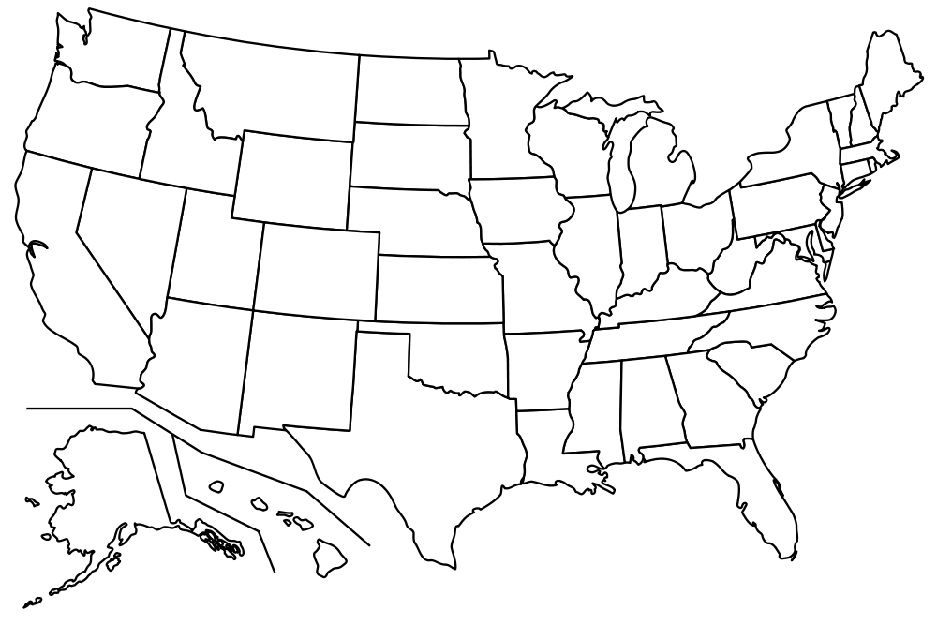

DOCUMENT CHOSEN FOR HAPP: DOCUMENT QUESTIONS:

H(istorical context):

A(udience):

P(urpose):

P(oint of view):

