PEOPLE IN WORLD HISTORY: Marie Antoinette (1755 – 1793)

“Courage?!? I have shown it for years; think you I shall lose it at the moment when my sufferings are to end?”
~ Marie Antoinette on the way to the guillotine, 1793

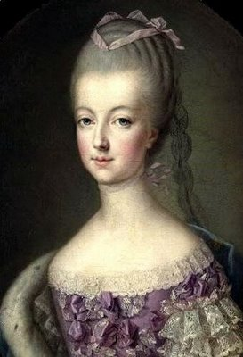
From childhood, Marie had been told that she would someday be a queen. At the age of 15, she was married to the French dauphin, or crown prince. In only four years, he became King Louis XVI, and Marie Antoinette—at the age people today graduate from high school—became the queen of France
Like many royal marriages of the day, the one between Marie and Louis was based not on love, but on politics. The marriage was arranged to strengthen France’s ties with Marie’s native Austria. Unhappy in her marriage, Marie sought comfort in elaborate parties at Versailles, horse races, and lavish theater productions. In her extravagance, Marie became an important symbol of royal excess and indifference. As such, her influence on the French Revolution was incalculable.
Marie’s reputation was under attack for much of her reign, although not always justifiably. The quote most commonly associated with Marie is “Let them eat cake.” This was supposedly her unthinking reply to a courtier’s remark that peasants were rioting outside her palace because they had no bread. History shows she probably never said these words, but the fact that people were willing to believe otherwise says much about the way the public perceived her. Many French citizens viewed Marie as simply frivolous. Others thought she was dangerous, an untrustworthy foreigner who would plot against France. Indeed, Marie tried constantly to influence French foreign policy to benefit her native Austria. When France went to war with Austria in 1792, Marie, who hoped for the defeat of the French revolutionaries, passed information to the enemy. Her treason gave the National Convention a reason to try and convict the queen. She was guillotined on October 16, 1793.
The last years of Marie’s life were full of heartache. She spent four years as a virtual prisoner of the revolutionaries. In her final months, her husband was executed and her surviving son was taken from her. Surprisingly, the superficial queen demonstrated remarkable character during these tragedies. Accounts of the time portray her as courageous, steadfast, and above all else, dignified as she approached the guillotine. Her noble death, in such contrast to her frivolous life, is one reason why Marie Antoinette has intrigued people for generations.

REVIEWING THE PROFILE. Answer the following in complete sentences and in your own words.
- How did Marie Antoinette become the queen of France? What purpose did her marriage serve?

- Why was she so unpopular with the French people?

- Does it surprise you that Marie Antoinette, famous for her frivolity, demonstrated such character at the end of her life? Explain your answer.

