1. Refer to the image below as you consider A, B, and C.
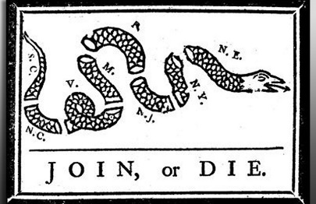
A. Explain ONE event that happened between 1763 and 1776 that deepened colonists’ sense of common cause.
B. Explain ONE political or cultural resource they shared in common as they drew together to resist imperial authority.
C. Explain ONE way colonists organized to oppose British power so effectively.

2. Explain how the Philadelphia convention resolved the following three contentious political issues:
A. Representation of large and small states
B. Slavery
C. Scope of federal power

2. Explain how the Philadelphia convention resolved the following three contentious political issues:
A. Representation of large and small states
B. Slavery
C. Scope of federal power

ANS:

• Representation: The delegates created a new government based on a combination of the New Jersey and Virginia plans: the Great Compromise/Sherman’s Compromise/the Connecticut Compromise. They created a bicameral legislature that reflected the needs of small and large states. Every state was allowed to send two members to the Senate, while in the House, where representation depended on population, the largest states would have the most representatives.

• Slavery: The major conflict over slavery was how slaves would count in a state’s population for the purposes of determining representation in the House of Representatives. The convention delegates compromised by determining that each slave would count as three-fifths of a person. Other conflicts over slavery were resolved by the delegates’ agreement to place a twenty-year moratorium on the Atlantic slave trade; to treat other aspects of slavery as political rather than moral issues, agreeing to a fugitive slave cause that allowed masters to reclaim slaves who escaped to other states; and refusing to mention the word “slave” in the Constitution.

• Federal power: The delegates agreed to preserve state sovereignty in the Constitution by restricting the central powers of the national government through the use of state rather than national courts. Voters in national elections did not have to be landowners, and the president of the nation would be chosen by an electoral college chosen on a state-by-state basis. The Bill of Rights, later passed as promised, also represented limits on federal power in favor of individual rights as well as local and state powers.

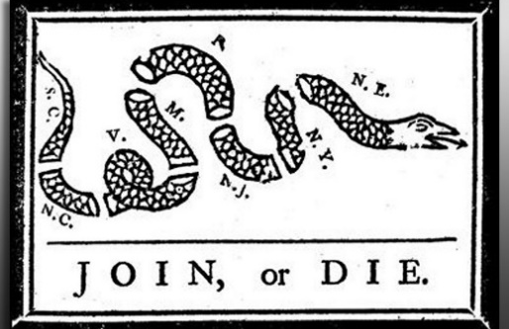
1. Refer to the image as you consider A, B, and C.
A. Explain ONE event that happened between 1763 and 1776 that deepened colonists’ sense of common cause.
B. Explain ONE political or cultural resource they shared in common as they drew together to resist imperial authority.
C. Explain ONE method colonists used to organize to oppose British power.

ANS:

• Events: Britain’s efforts to consolidate its imperial authority through taxation, a military presence, and direct rule affected all the colonies and helped to unite them behind a common cause. Students can list specific Acts, Taxes, or other forms of direct governance and/or interference, as long as they fit the time frame. (Examples: Stamp Act, Townshend Acts, Boston Massacre, Tea Tax of 1773, Coercive/Intolerable Acts, Lexington and Concord)

• Political or cultural resources: As early as 1765, in response to the Stamp Act, the colonists began to assemble to plan and coordinate resistance to British policies. They formed the Stamp Act Congress in October 1765 to protest the loss of American rights and liberties, and challenged the constitutionality of the Stamp and Sugar Acts. Nonimportation and organizations like the Sons and Daughters of Liberty drew colonists together. Colonists later formed more permanent institutions to plan and coordinate resistance, including the Committees of Correspondence and the First and Second Continental Congresses. These would come to serve as governing bodies in the period leading up to and including the American Revolution.

• Method - publications: Newspapers, pamphlets, and other publications that resulted from the print revolution publicized both British policies and Americans’ efforts to resist them. They disseminated philosophical, economic, and constitutional challenges to British policies and assumptions, and they mobilized further resistance and opposition to those policies.

