Central and South America Name:

Label each nation (including Puerto Rico, the Galapagos Islands, and the Falkland Islands) and the following cities using the maps on pages RA6-8.

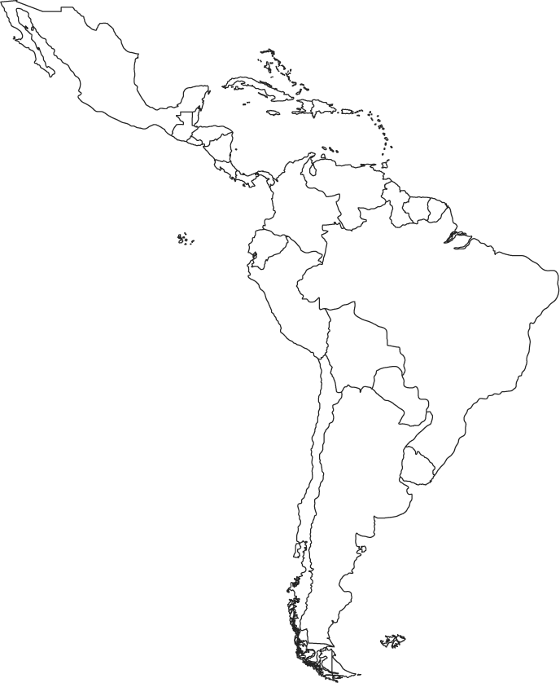
Cities:
- Kingston
- Mexico City
- San Salvador
- San Jose
- Havana
- Nassau
- Bogota
- Lima
- Santiago
- Buenos Aires
- Sao Paulo
- Rio de Janeiro
- Brasilia

