1.C.3: The Rise and Fall of Napoleon
Unit 1 – Revolutions NAME:
DIRECTIONS: As you read section 18-3 in the textbook, decide if the statement is true or false. Write T if the statement is true and F if the statement is false. For all false statements, write a corrected statement in the blank below that item. For true statements, provide a supporting detail in the blank.
_____ 1. Napoleon was born a French citizen.
______________________________________________________________________________________________________________________________________________________________
_____ 2. Napoleon rose quickly through the ranks of the French military, and was made a brigadier general at the age of 24.
______________________________________________________________________________________________________________________________________________________________
_____ 3. When Napoleon led a coup d’etat against the Directory, he became essentially an absolute ruler.
______________________________________________________________________________________________________________________________________________________________
_____ 4. One of Napoleon’s biggest accomplishments was the Civil Code—also known as the Napoleonic Code—which repealed most of the Enlightened changes of the French Revolution.
______________________________________________________________________________________________________________________________________________________________
_____ 5. Napoleon shut down 60 of France’s 73 newspapers and insisted that manuscripts be approved by the government before publication.
______________________________________________________________________________________________________________________________________________________________
_____ 6. Nationalism made it very difficult for Napoleon to amass his huge armies.
______________________________________________________________________________________________________________________________________________________________
_____ 7. Napoleon’s most famous defeat was at the Battle of Waterloo in England.
______________________________________________________________________________________________________________________________________________________________
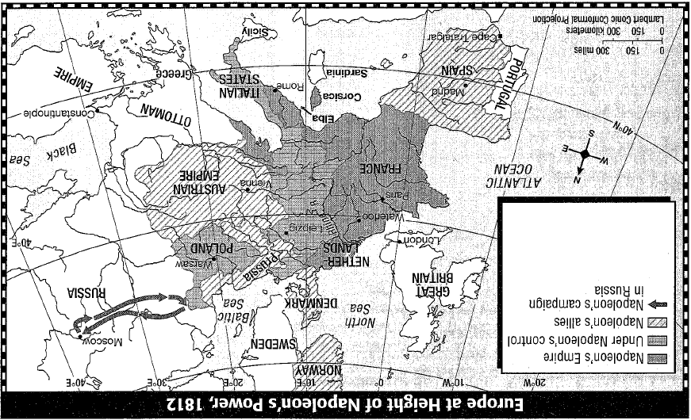
MAPPING HISTORY ACTIVITY
Napoleon Bonaparte so dominated Europe that the years 1800 to 1815 are often called “The Napoleonic Era.” At the height of his power, Napoleon controlled virtually the entire continent.
DIRECTIONS: The map below illustrates the remarkable extent of Napoleon’s influence. Use the map to answer the questions and complete the activity that follows.
- What nations were under his control?
- What nations did he make his allies?
- When was Napoleon’s power at its height?
- Add a symbol for battles in the symbol key.
- Using that symbol, mark the location of the battles of Trafalgar, Leipzig, and Waterloo battles on the map and label them with the year the battle took place.

