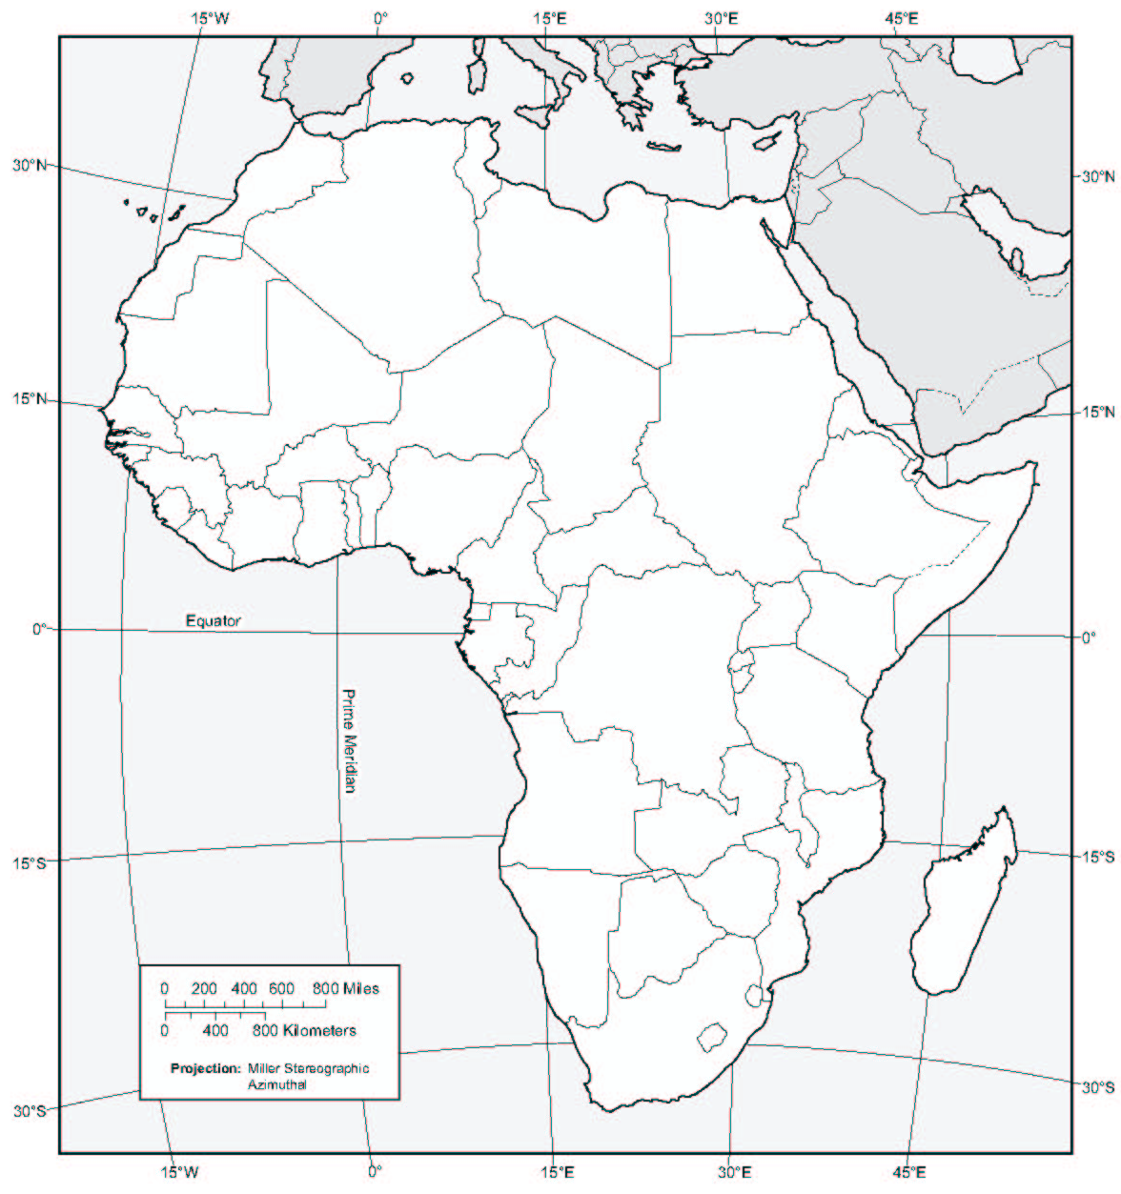
THE BERLIN CONFERENCE: IMPERIALISM IN AFRICA
KEY
Map Exercise Instructions

Use your textbook to provide the following information on the map of Africa on the reverse side of this page. Be sure to work carefully and neatly, as you will be providing a variety of information in a relatively small space.

First, label all of the countries of Africa:

- Algeria
- Angola
- Benin
- Botswana
- Burkina Faso
- Burundi
- Cameroon
- Central African Republic
- Chad
- Comoros
- Congo, Democratic Republic of
- Congo, Republic of
- Cote d'Ivoire (Ivory Coast)
- Djibouti
- Egypt
- Equatorial Guinea
- Eritrea
- Ethiopia
- Gabon
- Gambia, The
- Ghana
- Guinea
- Guinea-Bissau
- Kenya
- Lesotho
- Liberia
- Libya
- Madagascar
- Malawi
- Mali
- Mauritania
- Morocco
- Mozambique
- Namibia
- Niger
- Nigeria
- Rwanda
- Sao Tome and Principe
- Senegal
- Sierra Leone
- Somalia
- South Africa
- South Sudan (draw the border)
- Sudan
- Swaziland
- Tanzania
- Togo
- Tunisia
- Uganda
- Western Sahara
- Zambia
- Zimbabwe

Next, create a color-code to indicate the colonial possessions of the following European nations according to the Berlin Conference of 1884 (use the map in the book entitled “Imperialism in Africa, 1914”). Be sure to explain your color-code in the key provided on the map. NOTE: The borders of these colonies may or may not correspond to the modern borders on your map.

- Belgium
- France
- Germany
- Great Britain
- Italy
- Portugal
- Spain
- Independent African Nations

