The Italian Renaissance Name:

Three characteristics: define and describe below.

Characteristic 1:

Define Urban society:

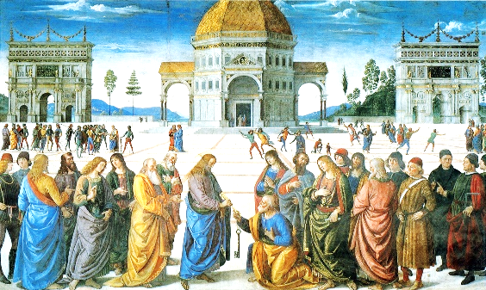
Define Secular:

Characteristic 2:

Characteristic 3:

The Italian States: In general what role did the city-states of Italy play?

Define Mercenaries:
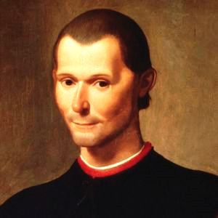

Machiavelli and the New Statecraft: summarize below.

Renaissance Society: Summarize in six words or less.

Nobility: what three characteristics does Castiglione’s perfect courtier have?

Peasants and townspeople: why does serfdom decrease?

What are the “three levels” of urban society?

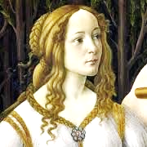
Family and marriage: summarize below in ten words or less.

Define Dowry:

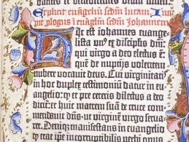
The Impact of Printing: what effect did the print revolution have?

Using ten adjectives, describe the Renaissance below.

