Resolution: Creating a Lasting Peace
World War I and Its Aftermath NAME: HR:
Use the information in section 23-4 (pg 739-744) in your textbook to answer each of the following questions in a complete sentence.
- What three things did the arrival of American troops provide to the Allies?

- What event brought hope of a successful end to the war to German troops in early 1918?

- Where and when was the last German offensive on the Western Front stopped?

- What event had to take place before Allied forces would accept a German surrender?

- What does the word armistice mean? On what date did the new German government sign an armistice?

- Following World War I, what became of the Austro-Hungarian Empire?

- a. What name did United States president Woodrow Wilson give to the peace settlement he proposed to Congress in the finals days of World War I?

b. What were some of the major components of this plan?

- What were the major goals of British Prime Minister David Lloyd George and French Premier Georges Clemenceau as they entered the Paris Peace Conference?

- What name was given to the international peacekeeping organization created by the Treaty of Versailles?

- Provide three major provisions of the Treaty of Versailles that sought to punish and/or embarrass the German people:

Use your textbook to provide the specified information to the maps on this page. Make sure to work carefully and neatly, as you will be providing a variety of information in a relatively small space.
Europe During World War I, 1914-18
On the map titled “Europe During World War I, 1914-18”:
- Create a color key that indicates “Central Powers”, “Allies”, and “Neutral Nations”.
- Color each nation on the map the appropriate color.
- Draw and label the border of the region known as the Balkans.

On the map titled “Europe After World War I, 1919”:
- Label the names of all European countries as of 1919.
- Create a color key that indicates “Nations Gaining Territory”, “Nations Losing Territory”, and “Newly-Formed Nations”.
- Color all nations affected by your color-code the appropriate color.
KEY
[ ]
[ ]
[ ]
- - - -
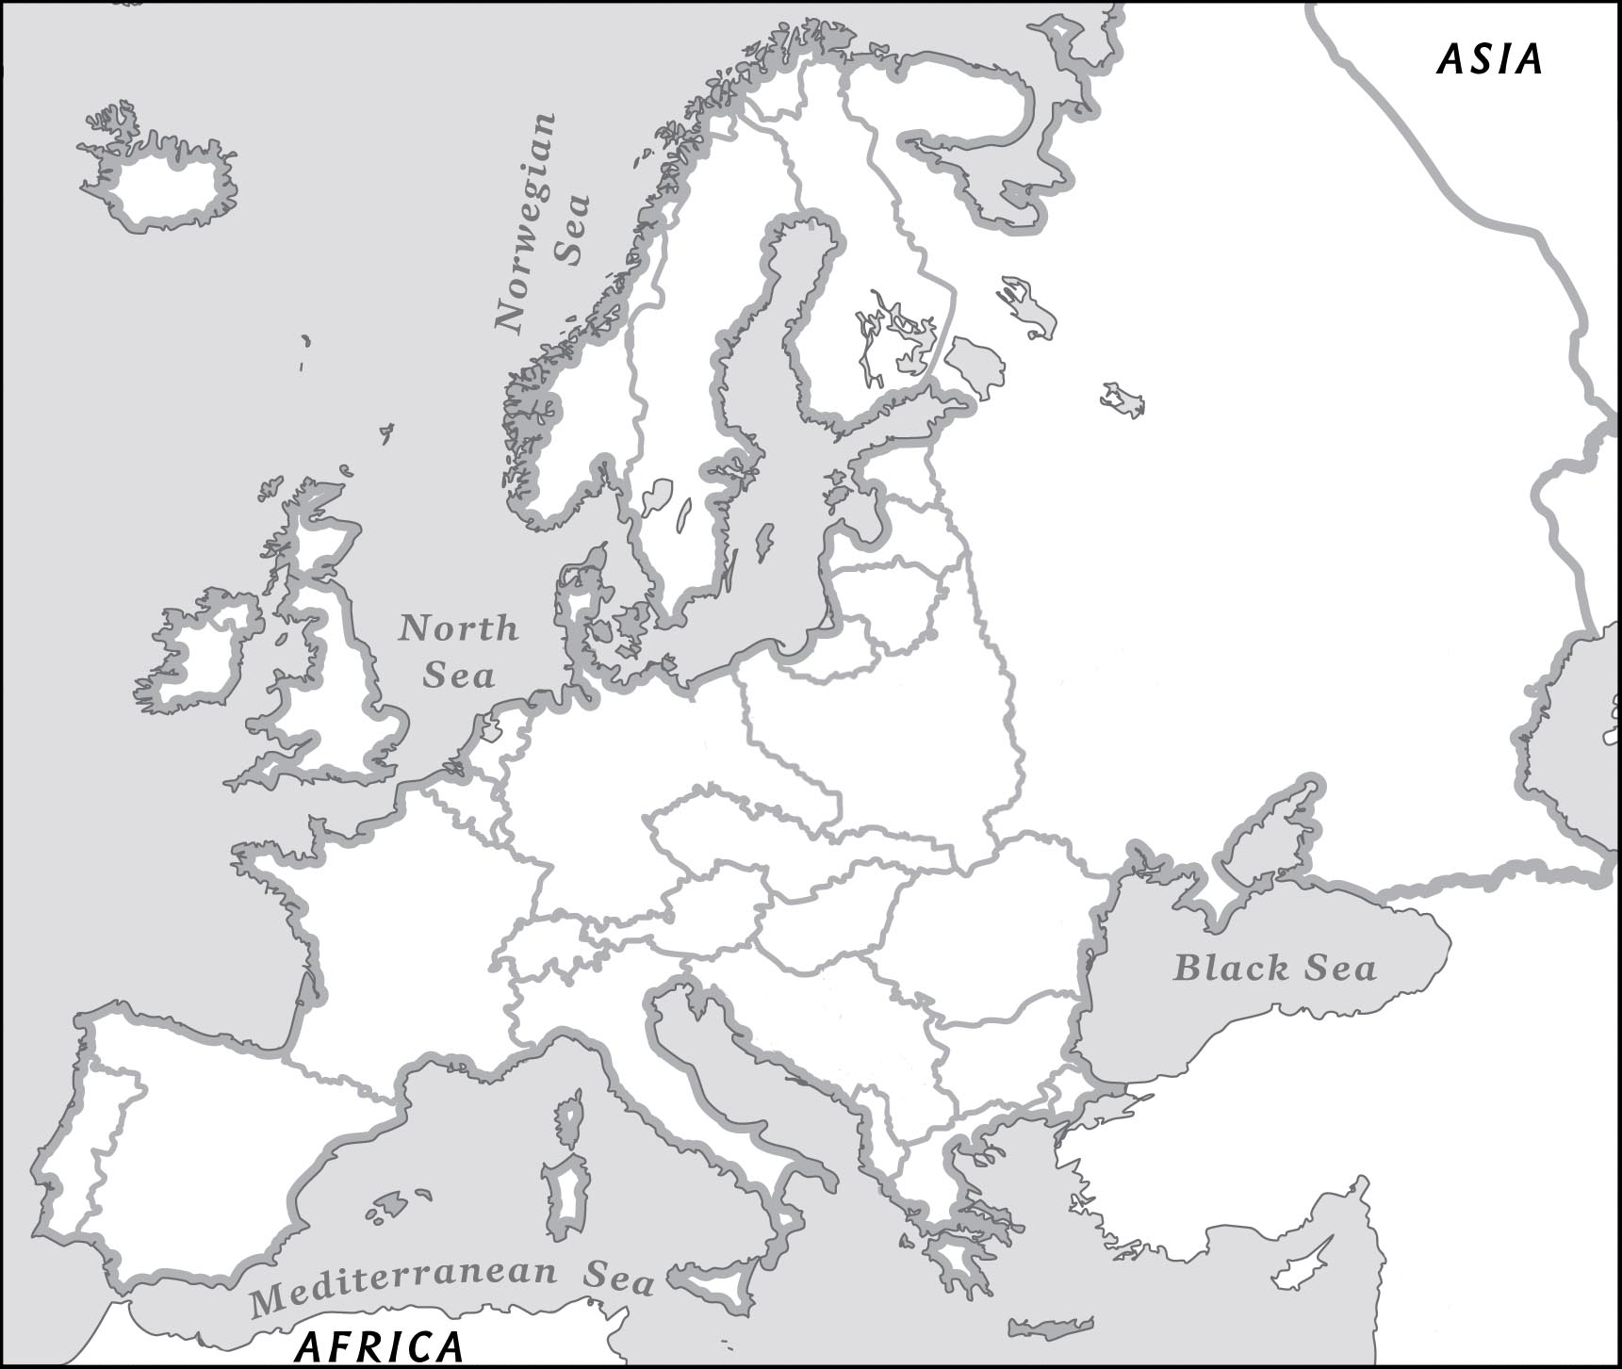
Europe After World War I, 1919

KEY
[ ]
[ ]
[ ]

KEY
[ ]
[ ]
[ ]

