Independence in Africa (30.1) – Presentation version
- Transitioning to independence
  - Europe controlled most of Africa by 1900
  - Post WWII: European nations letting go of colonies
    - GB and FR letting go in late 1950s and 60s- most black African nations achieved independence around this time
      - Examples: Gold Coast (renamed Ghana); Nigeria; Belgian Congo (renamed Zaire and is now Democratic Republic of the Congo); Kenya
      - 17 nations emerged in 1960, and 11 were reborn between 1961 and 1965.
      - French surrendered Morocco and Tunisia in 1956, and Algeria followed in 1962 after an 8-year long guerilla war that pitted the National Liberation Front against the French gov’t, headed by Charles de Gaulle
    - Portuguese surrendered Mozambique and Angola in 1970s
    - South Africa is its own story.
      - 17th century: Dutch settlers had arrived (Boer/Afrikaner population)
      - These whites dominated the government
      - African National Congress (ANC) formed in 1912
        - Goal was economic and political reform for blacks
      - 1950s: Afrikaners had strengthened segregation: system known as apartheid
      - Blacks protested apartheid, despite brutal repression
      - 1960: Sharpeville Massacre*
        - Peaceful march; 69 killed, 2/3 shot in back
      - Nelson Mandela arrested in 1962; ANC called for armed resistance to white gov’t afterward

- New Nations
  - New African Leaders: most were urban middle class and were educated abroad
    - Different views on economics
      - Western-style capitalism: Jomo Kenyatta of Kenya and General Mobutu Sese Seko of Dem. Rep. of Congo
      - “African socialism”: Julius Nyerere of Tanzania and Kwame Nkrumah of Ghana
        - Not like USSR’s socialism
        - Based on African traditions of community; ownership of a nation’s wealth belonged to the people
    - Pan-Africanism – unity of all black Africans in to a broad group of nations; common identity
      - Organization of African Unity (OAU) first incarnation
      - African Union (AU) replaced OAU in 2002
        - Promotes democracy and economic growth
    - Economic problems
      - Single-crop economies were volatile
        - Example: Liberia and rubber; Nigeria and oil
      - African states forced to import manufactured goods and technology
      - Unwise spending of national wealth
      - Corruption and bribery
      - Drought led to hunger and starvation
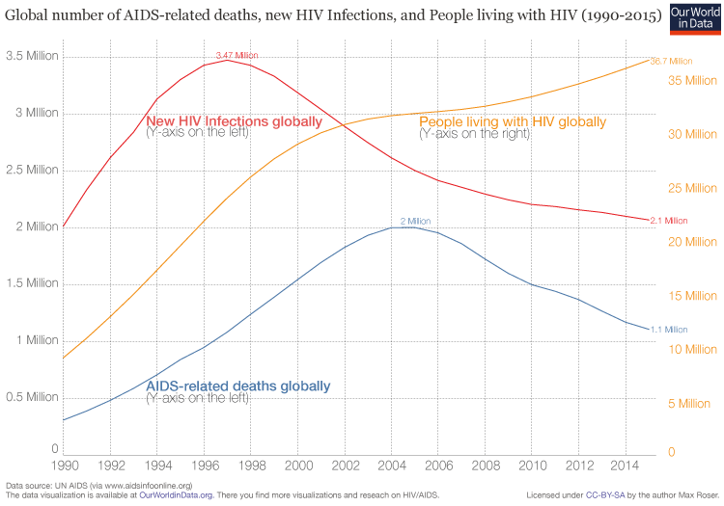
      - AIDS* What trends do you notice on the graph below?

      - Poverty widespread: what are some concurrent problems? Population pressure on cities; rise of slums/poorer-quality housing on edges of cities; strains on city sanitation and transportation networks leads to pollution, perpetual traffic jams, and similar problems
      - Millions go without water or electricity hooked up to houses
      - Rich are known as “wabenzi” for their Mercedes-Benz cars: exemplifies incredible wealth gap
    - Political challenges
      - “one person, one vote” (democracy) turned into military regimes and one-party states after independence in too many places
      - Between 1957 and 1982, over 70 African leaders were overthrown by violence
      - Concept of nationhood undermined by ethnic groups in conflict (thanks, European colonizers who didn’t care about drawing state boundary lines in accordance with tribal/ethnic boundaries!)
      - Examples
        - Biafra region in Nigeria* Nigeria was torn apart by civil war during the 1960s; the Ibo of Northern Nigeria experienced violence and moved toward the eastern part of Nigeria, declaring its independence as the state of Biafra. The rebellion was put down after a couple years of fighting, and what was almost Biafra finally accepted the control of the central Nigerian government
        - Rwandan Genocide (Hutus killed 500,000+ Tutsis)
          - Your textbook doesn’t call this a genocide. Why might that be?
- New Hopes
  - Popular movements have led to the collapse of restrictive regimes
    - Example: Dictator Idi Amin of Uganda was deposed in 1979; followed by brutal civil war, though
  - Nelson Mandela and the end of apartheid
    - 1962: sentenced to life on Robben Island for activities with ANC
    - Still worked for freedom and equality
    - 1985: refused to accept conditional release
    - Nobel winner Bishop Desmond Tutu and others worked to free Mandela and end apartheid; they helped to shine a spotlight on the horrible fact of apartheid, and this embarrassed South Africa, which was trying to portray itself as a forward-thinking nation in order to attract investors to grow the economy.
    - Worldwide pressure led to reforms and gradual end of apartheid
    - 1990: Mandela released
    - 1993: Pres. De Klerk agreed to hold democratic elections
    - 1994: Mandela elected President and official end of apartheid
      - Inaugural address: “We shall build a society in which all South Africans, both black and white, will be able to walk tall, without any fear in their hearts, assured of their inalienable right to human dignity—a rainbow nation at peace with itself and the world.”

