http://history.howstuffworks.com/historical-figures/spanish-inquisition.htm
Nobody expects the Inquisition!
Introducing the Spanish Inquisition
From Monty Python, you can guess that the Spanish Inquisition must've involved torture and the Catholic Church. But why? Who was on the receiving end of that torture?
The Spanish Inquisition was just one of several inquisitions that occurred between the 12th and 19th centuries. In addition to the term being used for the historical events, the word "inquisition" refers to the tribunal court system used by both the Catholic Church and some Catholic monarchs to root out, suppress and punish heretics. These were baptized members of the church who held opinions contrary to the Catholic faith. Because of its association with torture and execution, inquisition remains a controversial and difficult subject.

The Beginnings of the Spanish Inquisition
Although early Christians experienced heavy persecution, by the Middle Ages, the Catholic Church had significant religious and political power in Europe. To maintain its authority, the church suppressed heretics. The church had a very specific definition of heresy: A heretic publicly declared his beliefs (based upon what the church considered inaccurate interpretations of the Bible) and refused to denounce them, even after being corrected by the authority. He also tried to teach his beliefs to other people. He had to be doing these things by his own free will, not under the influence of the devil.
…The Spanish Inquisition was unique in that it was established by secular rulers, King Ferdinand II and Queen Isabella, with the approval of Pope Sixtus IV. The monarchy was Catholic, and it had just united two kingdoms, Aragon and Castile, as a single country in the late 15th century. Reasons for the Inquisition included a desire to create religious unity and weaken local political authorities and familial alliances. Money was another motive -- the government made a profit by confiscating the property of those found guilty of heresy. Historians speculate that the monarchy convinced Pope Sixtus IV to allow the inquisition by threatening to remove Spanish troops from Rome, where they were needed to prevent an attack by Turkey.
Many prominent citizens were concerned about their country's religious diversity and had bigoted attitudes toward non-Catholics. Jews were subjected to violent attacks known as pogroms and isolated in ghettos. Many were killed. The Inquisition was officially established in 1478, and Jews were banished a few years later when King Ferdinand II issued the Alhambra Decree in 1492, ordering them to leave on pain of death. Many Jews converted to Catholicism. These converts were sometimes called marranos (Spanish for "pig" and a very derogatory term) and accused of secretly continuing to practice Judaism. They became targets of the Inquisition.
Spain conquered Granada, a region populated mostly by Muslim Moors, in the late 15th century. Muslims suffered opposition, censorship, and persecution similar to that of the Jews, until they were banished in 1502 in the name of religious and cultural unity. Muslim converts to Catholicism, called Moriscos (Spanish for "Moorish"), were targeted for the same reasons as Jewish converts. In the late 16th century, Protestants, mainly Lutherans, also became the target of the Inquisition. The Spanish Inquisition also spread to Spanish-controlled colonies in the New World, including Mexico.

Spanish Inquisition Trials
As mentioned earlier, the inquisitions were tribunals -- a type of trial where the judge (or judges) tries the accused and passes judgment. But these trials were unique in several ways. The accused was required to testify, and he didn't get a lawyer or any assistance. If he refused to testify, the Inquisitor took this refusal as proof of his guilt. Anybody could testify against him, including relatives, criminals and other heretics, and he wasn't told who his accusers were. The accused usually didn't have any witnesses testify on his behalf, because they could also fall under suspicion of being a heretic. He also wasn't always immediately informed of the charges against him.
Heresy could be definitively proven if the accused was caught in a heretical act, but the goal of the inquisitor was always to extract a confession, or admission of guilt. Inquisitors were not only better educated and better versed in the Bible than their subjects; they were also specifically trained in how to question them in confusing or leading ways. Often, the accused wasn't clever enough to answer the inquisitor's questions and prove his innocence. But the inquisitor still needed a satisfactory confession. Accused heretics could be imprisoned for years until one was obtained.
In 1252, Pope Innocent IV had issued a bull (a decree) that allowed the use of torture to get a confession. In the 16th century, the Spanish inquisitors took advantage of this bull. This task was often assigned to local authorities, but the inquisitors themselves participated as well. If the accused confessed while being tortured, he had to confess again while not under torture for the confession to count. Torture was only supposed to be used if all other attempts at obtaining proof of heresy had been exhausted, and only one session was allowed (although one “session” may have portions that ran over a number of days; how restrictions on torture are followed often depends on the nature of the human carrying out the torture. The vast majority of victims of the inquisition were not tortured.

Torture and Punishment During the Spanish Inquisition
Torture was used only to get a confession and wasn't meant to actually punish the accused heretic for his crimes. Some inquisitors used starvation, forced the accused to consume and hold vast quantities of water or other fluids, or heaped burning coals on parts of their body. But these methods didn't always work fast enough for their liking.
Strappado is a form of torture that began with the Medieval Inquisition. In one version, the hands of the accused were tied behind his back and the rope looped over a brace in the ceiling of the chamber or attached to a pulley. Then the subject was raised until he was hanging from his arms. This might cause the shoulders to pull out of their sockets. Sometimes, the torturers added a series of drops, jerking the subject up and down. Weights could be added to the ankles and feet to make the hanging even more painful.
The rack was another well-known torture method associated with inquisition. The subject had his hands and feet tied or chained to rollers at one or both ends of a wooden or metal frame. The torturer turned the rollers with a handle, which pulled the chains or ropes in increments and stretched the subject's joints, often until they dislocated. If the torturer continued turning the rollers, the accused's arms and legs could be torn off. Often, simply seeing someone else being tortured on the rack was enough to make another person confess.
While the accused heretics were on strappado or the rack, inquisitors often applied other torture devices to their bodies. These included heated metal pincers, thumbscrews, boots, or other devices designed to burn, pinch or otherwise mutilate their hands, feet or bodily orifices. Although mutilation was technically forbidden, in 1256, Pope Alexander IV decreed that inquisitors could clear each other from any wrongdoing that they might have done during torture sessions.
Inquisitors needed to extract a confession because they believed it was their duty to bring the accused back to the faith. A true confession resulted in the accused being forgiven, but he was usually still forced to absolve himself by performing penances, such as pilgrimages or wearing multiple, heavy crosses. If the accused didn't confess, the inquisitors could sentence him to life imprisonment. Repeat offenders -- people who confessed, then retracted their confessions and publicly returned to their heretical ways -- could be "abandoned" to the "secular arm.” Basically, it meant that although the inquisitors themselves didn't execute heretics, they could let other people do it.
Capital punishment did allow for burning at the stake. In some cases, accused heretics who had died before their final sentencing had their corpses or bones dug up, burned and cast out. The last inquisitorial act in Spain occurred in 1834, but all of the Inquisitions continued to have a lasting impact on Catholicism, Christianity and the world as a whole.

The Aftermath of the Inquisitions
While most people think of a single Inquisition, history isn't quite that simple. Most of the inquisitions had little to do with creating unity. Instead, the goal was to maintain authority and discourage rebellious behavior.
The Protestant Reformation in the 1520s and other Christian reform movements contributed to the idea of a single Inquisition masterminded directly by the Catholic Church. Because Spain was the greatest political power in Europe in the 16th century, Reformers focused on the inquisitions that took place in that country, although inquisitions also took place in Portugal, Rome, and other areas. In some cases, they exaggerated circumstances of the inquisitions to increase anti-Catholic, and therefore anti-Spanish, sentiment. Artists and philosophers of the 17th and 18th centuries also contributed to misunderstandings, because they took issue with the inquisition’s suppression of freedom and creativity. Some of the misunderstandings surrounding the inquisitions come from these artists’ symbolic or fictional accounts.

http://history.howstuffworks.com/historical-figures/spanish-inquisition.htm
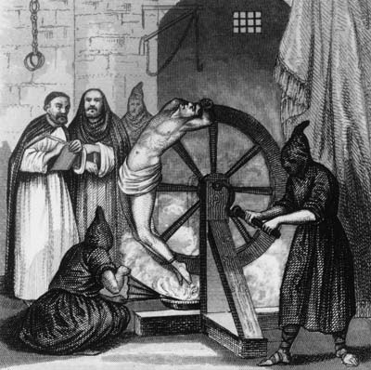
Circa 1500, A prisoner undergoing torture at the hands of the Spanish Inquisition. Monks in the background wait for his confession with quill and paper.
HULTON ARCHIVE/GETTY IMAGES

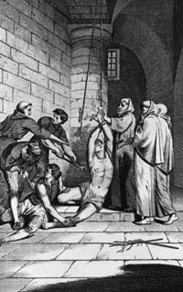

English merchant Nicholas Burton is tortured by officers of the Spanish Inquisition while imprisoned in Cadiz, 1560. He converted several of his fellow prisoners to the Protestant faith before he was martyred at the stake.
HULTON ARCHIVE/GETTY IMAGES

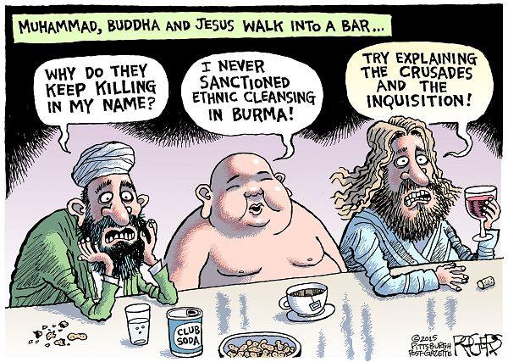
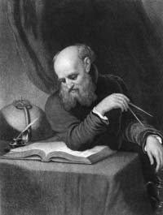
KEAN COLLECTION/GETTY IMAGES
http://history.howstuffworks.com/historical-figures/spanish-inquisition.htm

More Victims of Inquisition
Waldensians and Cathars, members of spiritual movements that gained popularity and threatened the authority of the Catholic Church, were the primary targets of the Medieval Inquisition.
The Portuguese Inquisition was similar to the Spanish Inquisition in that it operated under the monarchy. It was established in 1536 and targeted Jews and recent converts to Christianity, as well as accused witches. The Portuguese Inquisition extended to Portugal's New World colonies. A later Portuguese Inquisition, the Goa Inquisition, targeted Hindus as well.
The Roman Inquisition, established during the 1540s, focused on the heretical crimes of witchcraft, sorcery and blasphemy. One of its most famous cases was that of Galileo Galilei.

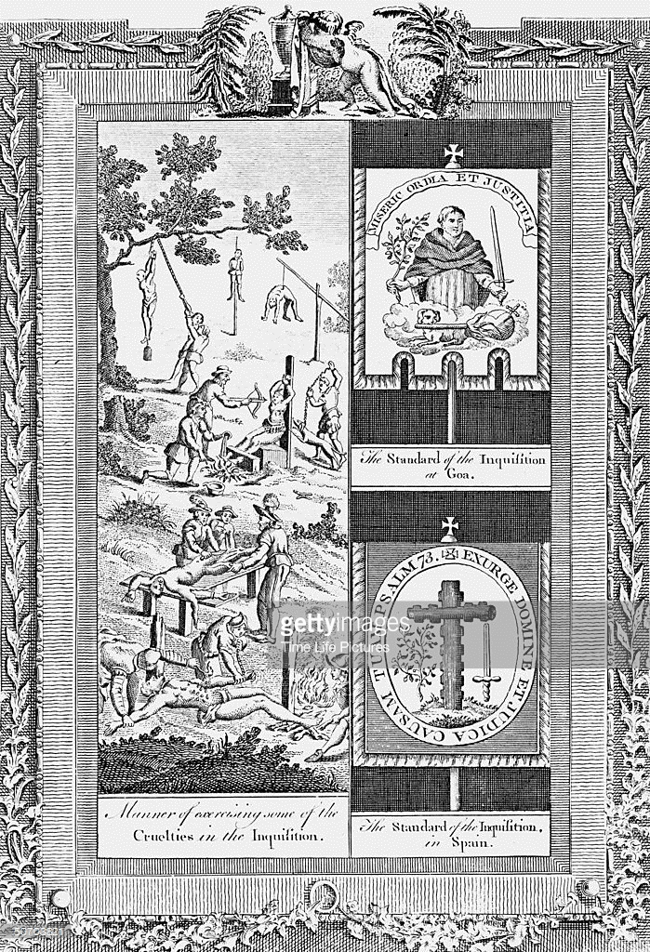

Composite engraving from Dr. Southwell's "New Book of Martyrs," showing tortures of the Spanish Inquisition
TIME LIFE PICTURES/MANSELL/TIME LIFE PICTURES/GETTY IMAGES
http://history.howstuffworks.com/historical-figures/spanish-inquisition.htm

The Top 10 Questions Everyone Has About the Inquisition
01/23/2012 03:52 pm ET | Updated Mar 24, 2012
http://www.huffingtonpost.com/cullen-murphy/10-questions-about-the-inquisition_b_1224406.html?scrlybrkr=9e4261d8
Cullen Murphy Author, ‘God’s Jury: The Inquisition and the Making of the Modern World’
In talking with audiences about my new book, “God’s Jury: The Inquisition and the Making of the Modern World,” I’ve found that the same questions come up over and over. Here are the Top 10.
1. I know what the word “Inquisition” means, even use the word myself sometimes, but my history is shaky. What does it refer to?
It was a means used by the Church to enforce orthodoxy. Inquisitors would go out into troublesome regions, question people intensively, conduct tribunals and mete out punishments, sometimes harsh ones, like burning at the stake. Depending on the time and place, the targets were heretics, Jews, Muslims, Protestants, rationalists and sometimes people who held superstitious beliefs. The Inquisition everyone has heard of is the Spanish Inquisition, but there was more than one Inquisition, and the earliest, at the start of the 13th century, wasn’t in Spain. And although Jews were sometimes the focus of that first Inquisition, as they primarily were in Spain, the more urgent targets were Christian heretics in the south of France and northern Italy.
2. How many people were burned at the stake?
No one really knows. The inquisitors were excellent record-keepers — at times truly superb. One surviving document gives the expenses for an execution down to the price of the rope used to tie the victims’ hands. But a lot of the records have been lost. An estimate that has wide credibility among historians is that about 2 percent of those who came before Inquisition tribunals were burned at the stake, which would mean several tens of thousands of people. The rest suffered lesser punishments.
3. Over what period of time are we talking about?
Roughly 700 years. The official start is usually given as 1231 A.D., when the pope appoints the first “inquisitors of heretical depravity.” The Spanish Inquisition, which begins under Ferdinand and Isabella, doesn’t end until the 19th century — the last execution was in 1826. At the outset, the main focus was on Jews and “judaizers” — Christian converts of Jewish ancestry who were accused of secretly adhering to Judaism. The Roman Inquisition, created to fight the Reformation, and run from the Vatican, doesn’t come to an end until the 20th century.
4. Does it survive in any form? I sometimes hear about theologians today getting into trouble.
The Vatican’s Congregation of the Inquisition was formally abolished in 1908 — but it may be more correct to say it was renamed. It was turned into the Holy Office, which in the 1960s became the Congregation for the Doctrine of the Faith. This is the department that Cardinal Josef Ratzinger ran before he became Pope Benedict XVI. It occupies the palazzo built for the Inquisition in the middle of the 16th century. And it’s still the department that keeps an eye on what theologians write, sometimes calling them on the carpet.
5. Does the Inquisition explain why Spain in some ways took longer to modernize than France or England?
Historians do ask this question, but you’ll get different opinions. The “yes” answer will point to the wholesale expulsion from Spain in 1492 of many thousands of Jews — people who were often highly educated professionals. And it will point to the attempted suppression, over centuries, of intellectual inquiry of all kinds. The same kind of suppression occurred in Italy. The problem is figuring out how effective the suppression really was, not to mention disentangling the influence of the Inquisition from other factors. Bottom line, though: No one argues that the Inquisition was a force for enlightenment.
6. Did Torquemada himself have Jewish ancestry?
Historians have looked into this pretty carefully. The consensus seems to be that Tomas de Torquemada, who directed the Spanish Inquisition in its earliest (and bloodiest) years, did not have Jewish ancestry, but other members of his extended family probably did. This wouldn’t have been unusual in Spain. Over the centuries there was considerable mixing among Christians, Muslims and Jews, especially in the higher ranks.
7. When I think “Inquisition,” I think “torture” — is that real or is it a myth?
Torture was an integral part of the inquisitorial process, mainly to extract confessions — just as it was part of the systems used by secular courts of the time. Modern historians explain that the Church tried to regulate torture, establishing clear guidelines for its use. Unfortunately, limitations on torture never really work — that’s one lesson from the Inquisition, and from the recent American experience. It’s never hard to justify applying a little more physical coercion once you’ve decided that physical coercion is fine to begin with. Medieval inquisitors, limited to one session of torture per person, sometimes conducted a second or third or fourth, arguing that it was just a “continuance” of the first.
8. Is waterboarding torture?
Vice President Dick Cheney called waterboarding “a dunk in the water.” The Justice Department attempted to define torture so narrowly that nothing came up to the torture threshold unless it risked causing irreversible impairment, organ failure or death. The inquisitors believed that waterboarding was torture. That’s why they used it.
9. How does the Index of Forbidden Books fit into the picture?
It was created by the Roman Inquisition to deal with the onslaught of books — many of them advancing ideas the Church didn’t like — made possible by the printing press, and over the centuries the Index grew and grew. It existed for a very long time — it wasn’t abolished until 1966. The impulse to criticize still has some life. A decade ago Josef Ratzinger expressed concern over the “subtle seductions” of Harry Potter.
10. The “Making of the Modern World” part of your title — what’s the argument?
The Inquisition was based on intolerance and moral certainty. It tried to enforce a particular view, often with violent means. There’s nothing new about hatred and persecution; human beings have been very good at this for millennia. What’s new about the Inquisition is that persecution is institutionalized. It persists for generation after generation. That requires organizational tools that were being newly developed in the Middle Ages. How do you create and manage a bureaucracy? How do you collect information and organize it in a way so that you can find what you need? How do you discover what people are doing and thinking? We take the ability to do all these things for granted. When you look at the Inquisition, you see these capabilities coming into existence. You see the world becoming modern.

Shadows of the Pomegranate Tree by Tariq Ali
posted in Books, Fiction, Islamic History
(First published 1991)
This book is the first in the series of five books labelled “Islam Quintet”. These books are historical novels which deal with a particular period in the history of Muslim civilisation. This one is about the dying days of the Muslim Spanish civilisation. The year of 1499, seven years after the reconquista of the last Muslim stronghold in Al-Andalus, forms the background. The Christians armies are consolidating their control on the whole of Al-Andalus. It is a time of intense stress for Muslims as they don’t know what would be done to them. The Inquisition on a large scale hasn’t yet started.
The narrative starts with the massive bonfire instigated by the Christian bishop Cisneros, who wants to remove all symbols of Moors from the face of Andalus. More than one hundred thousand books from all the Muslim libraries of Cordoba burn in this fire as the people – Muslims, Jews as well as knowledgeable Christians – stand there to watch in disgusted silence. The achievements of the rich Andalusian and Moorish civilisation is turned into ashes in full public view.
The story revolves around the family of Banu Hudayl who have lived in a small village outside Cordoba for at least 500 years. The head of this family belonged to the nobles of the Cordoba court before falling in the hands of the armies of Isabella and Ferdinand.
This family and others like them has painfully adjusted to the new reality. They hope that the new rulers would let them practice their religion and keep their language and identity. But news coming from different corners of the country suggests otherwise. Some members of this large and influential family have converted to Christianity in order to avoid annihilation and to continue to keep their property and businesses. Even then, they are constantly watched for being ‘fake Christians’.

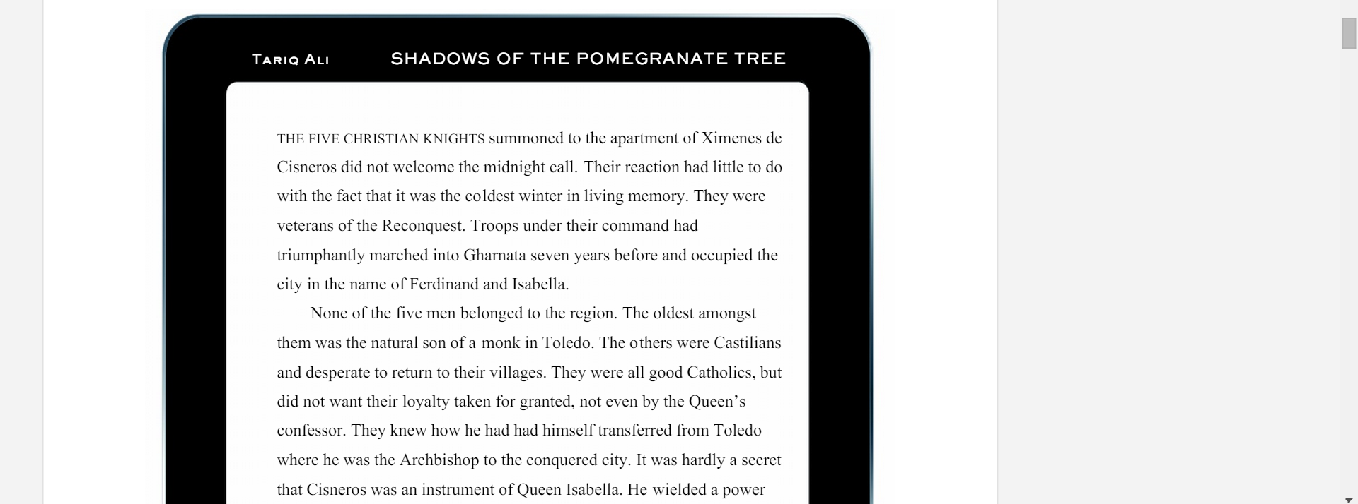
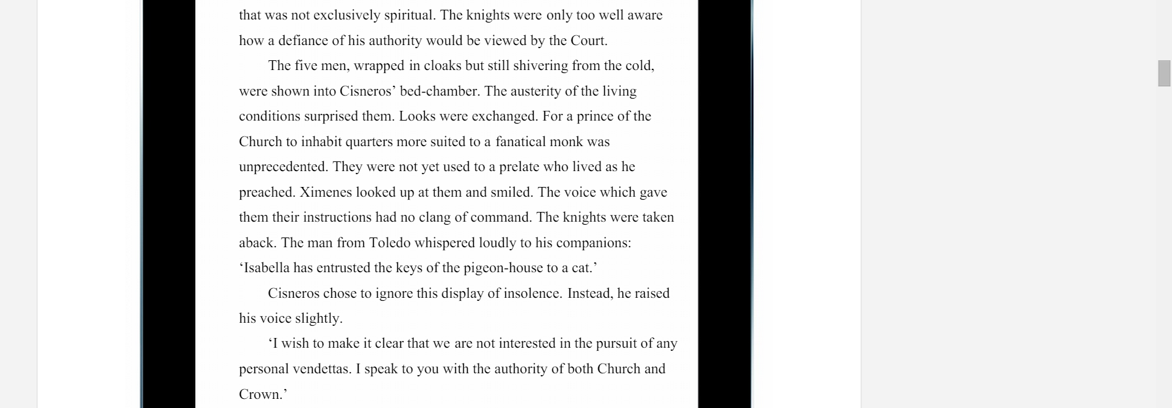
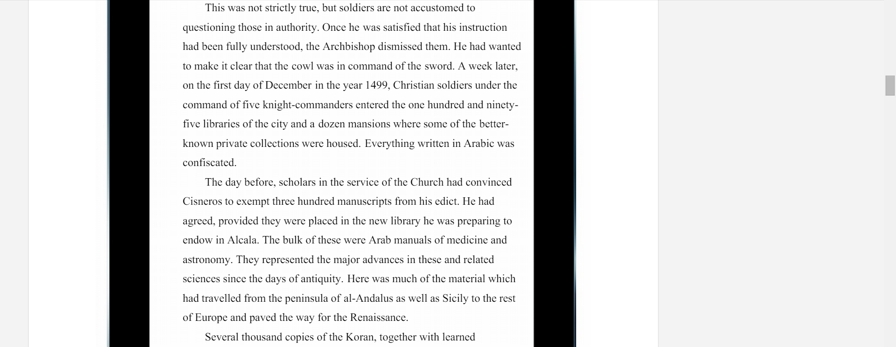
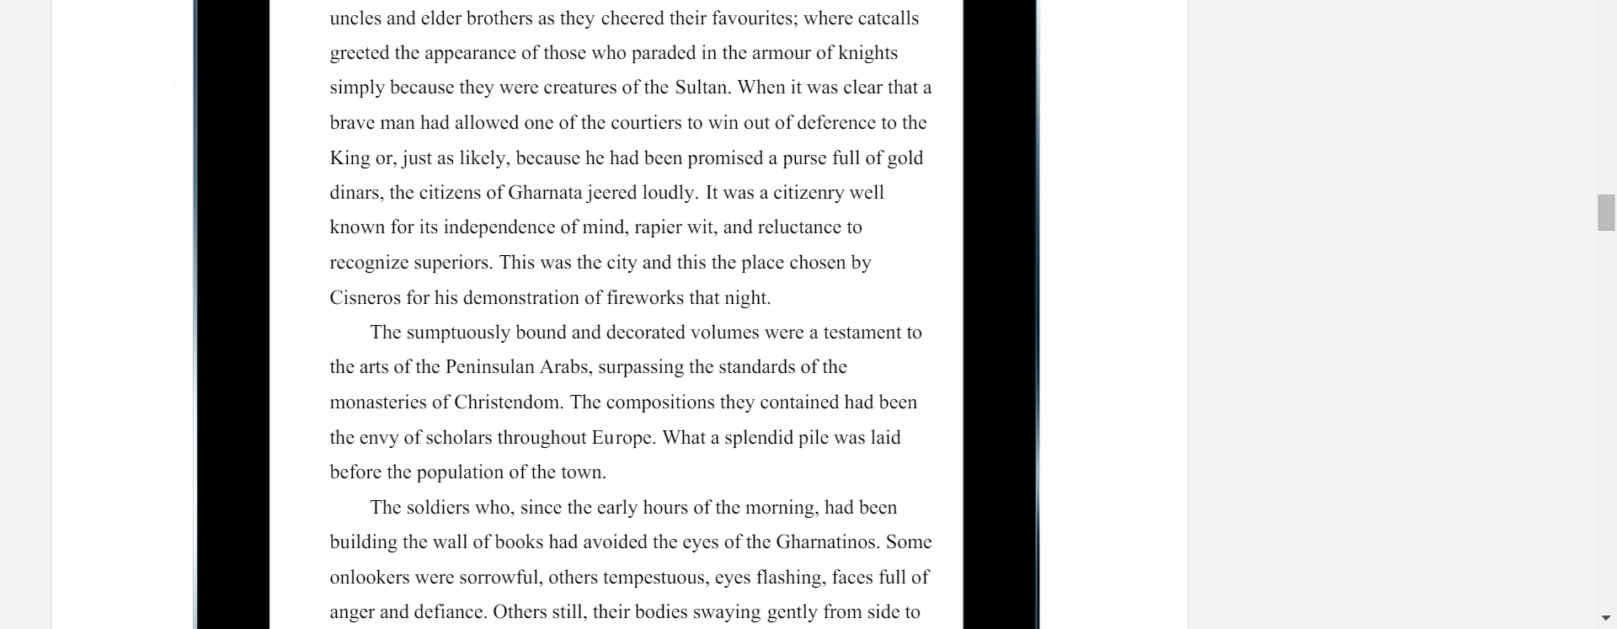
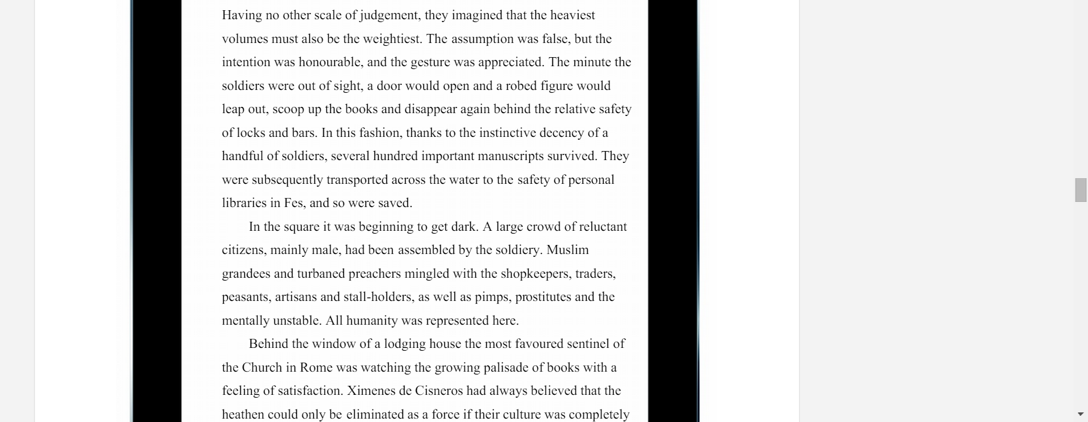
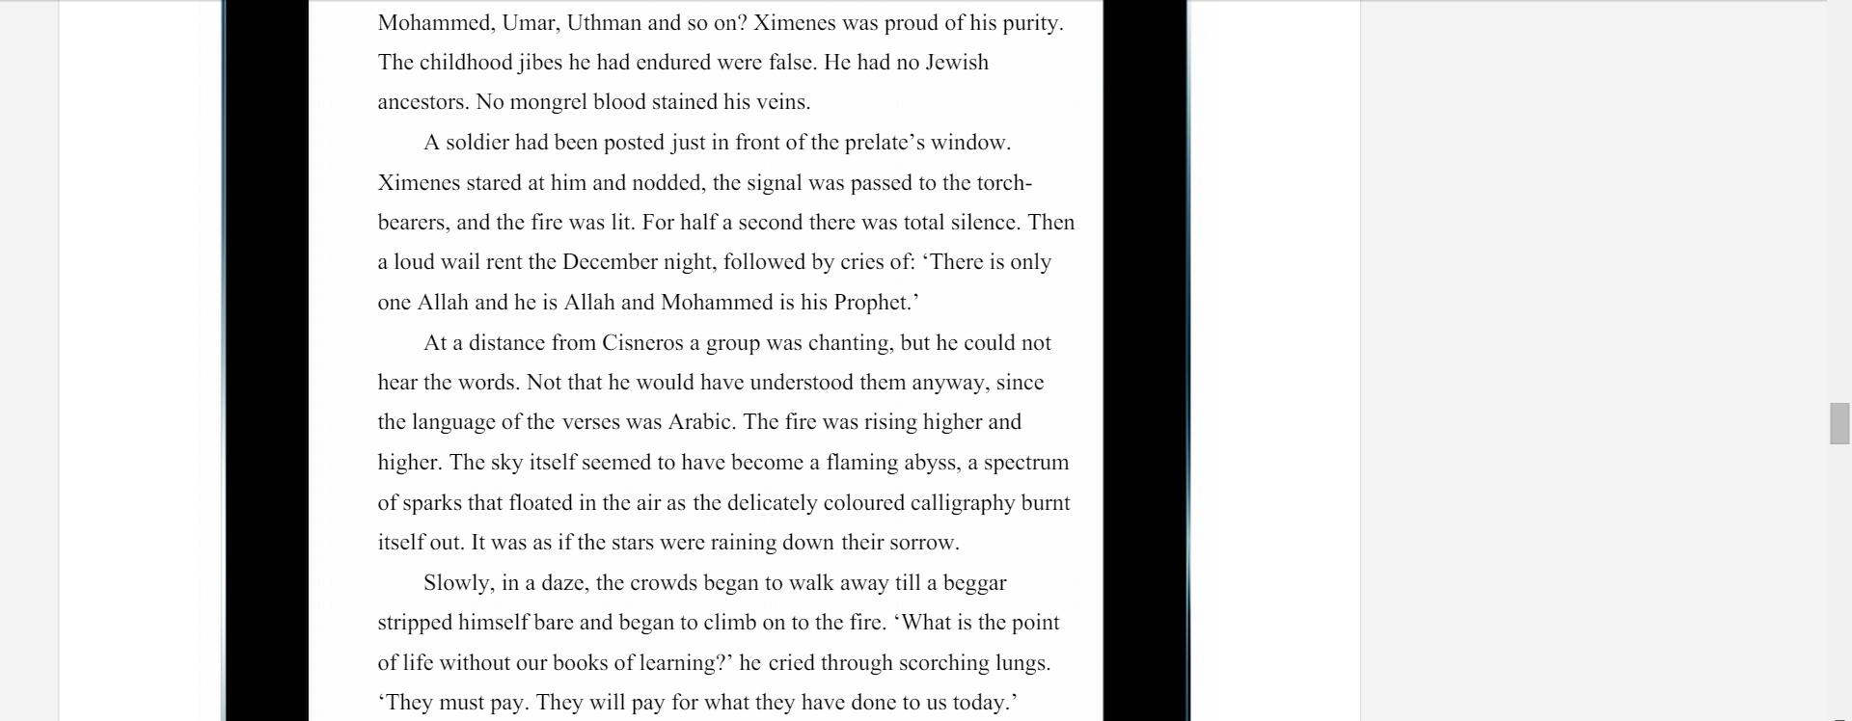

- 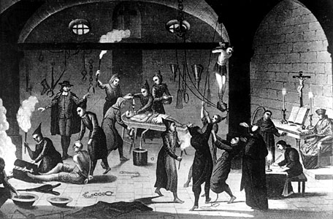

- Suspected Protestants being tortured as heretics during the Spanish Inquisition.
- Three Lions/Hulton Archive/Getty Images

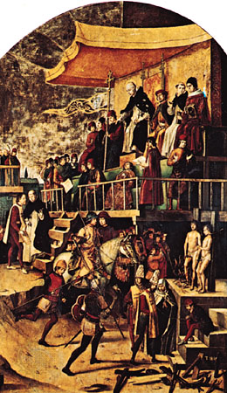
- St. Dominic Presiding at an Auto-da-Fé, panel
- Archivo Mas, Barcelona

- 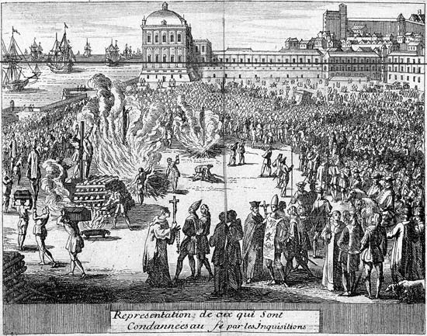
- The burning of condemned prisoners during the Spanish Inquisition.
- © Photos.com/Thinkstock

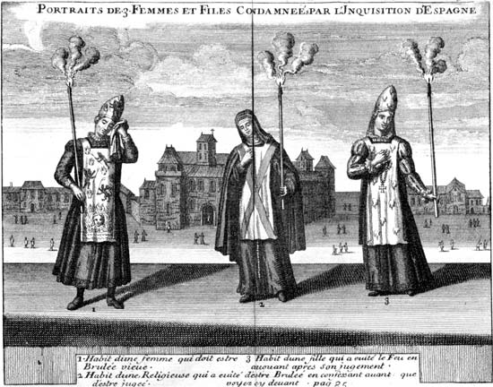zoom_in
Illustration depicting three women who were condemned by the Spanish Inquisition. © Photos.com/Thinkstock

Spanish Inquisition
SPANISH HISTORY [1478–1834]
TABLE OF CONTENTS
WRITTEN BY:
Edward A. Ryan
LAST UPDATED:
5-28-2015
BRITANNICA STORIES
Spanish Inquisition, (1478–1834), judicial institution ostensibly established to combat heresy in Spain. In practice, the Spanish Inquisition served to consolidate power in the monarchy of the newly unified Spanish kingdom, but it achieved that end through infamously brutal methods.

THE RISE OF THE SPANISH INQUISITION
The medieval inquisition had played a considerable role in Christian Spain during the 13th century, but the struggle against the Moors had kept the inhabitants of the Iberian Peninsula busy and served to strengthen their faith. When toward the end of the 15th century the Reconquista was all but complete, the desire for religious unity became more and more pronounced. Spain’s Jewish population, which was among the largest in Europe, soon became a target.
Over centuries, the Jewish community in Spain had flourished and grown in numbers and influence, though anti-Semitism had surfaced from time to time. During the reign of Henry III of Castile and Leon (1390–1406), Jews faced increased persecution and were pressured to convert to Christianity. The pogroms of 1391 were especially brutal, and the threat of violence hung over the Jewish community in Spain. Faced with the choice between baptism and death, the number of nominal converts to the Christian faith soon became very great. Many Jews were killed, and those who adopted Christian beliefs—the so-called conversos (Spanish: “converted”)—faced continued suspicion and prejudice. In addition, there remained a significant population of Jews who had professed conversion but continued to practice their faith in secret. Known as Marranos, those nominal converts from Judaism were perceived to be an even greater threat to the social order than those who had rejected forced conversion. After Aragon and Castile were united by the marriage of Ferdinand and Isabella (1469), the Marranos were denounced as a danger to the existence of Christian Spain. In 1478 Pope Sixtus IV issued a bull authorizing the Catholic Monarchs to name inquisitors who would address the issue. That did not mean that the Spanish sovereigns were turning over to the church the struggle for unity; on the contrary, they sought to use the Inquisition to support their absolute and centralizing regime and most especially to increase royal power in Aragon. The first Spanish inquisitors, operating in Seville, proved so severe that Sixtus IV attempted to intervene. The Spanish crown now had in its possession a weapon too precious to give up, however, and the efforts of the pope to limit the powers of the Inquisition were without avail. In 1483 he was induced to authorize the naming by the Spanish government of a grand inquisitor (inquisitor general) for Castile, and during that same year Aragon, Valencia, and Catalonia were placed under the power of the Inquisition.

THE INQUISITION AT ITS PEAK
The grand inquisitor acted as the head of the Inquisition in Spain. The ecclesiastical jurisdiction that he had received from the Vatican empowered him to name deputies and hear appeals. In deciding appeals, the grand inquisitor was assisted by a council of five members and by consultors. All those offices were filled by agreement between the government and the grand inquisitor. The council, especially after its reorganization during the reign of Philip II (1556–98), put the effective control of the institution more and more into the hands of the civil power. After the papacy of Clement VII (1523–34), priests and bishops were at times judged by the Inquisition. In procedure the Spanish Inquisition was much like the medieval inquisition. The first grand inquisitor in Spain was the Dominican Tomás de Torquemada; his name became synonymous with the brutality and fanaticism associated with the Inquisition. Torquemada used torture and confiscation to terrorize his victims, and his methods were the product of a time when judicial procedure was cruel by design. The sentencing of the accused took place at the auto-da-fé (Portuguese: “act of faith”), an elaborate public expression of the Inquisition’s power. The condemned were presented before a large crowd that often included royalty, and the proceedings had a ritualized, almost festive, quality. The number of burnings at the stake during Torquemada’s tenure was exaggerated by Protestant critics of the Inquisition, but it is generally estimated to have been about 2,000.
At Torquemada’s urging, Ferdinand and Isabella issued an edict on March 31, 1492, giving Spanish Jews the choice of exile or baptism; as a result, more than 160,000 Jews were expelled from Spain. Francisco, Cardinal Jiménez de Cisneros, promoted the suppression of Muslims with the same zeal that Torquemada had directed at Jews. In 1502 he ordered the proscription of Islam in Granada, the last of the Muslim kingdoms in Spain to fall to the Reconquista. The persecution of Muslims accelerated in 1507 when Jiménez was named grand inquisitor. Muslims in Valencia and Aragon were subjected to forced conversion in 1526, and Islam was subsequently banned in Spain. The Inquisition then devoted its attention to the Moriscos, Spanish Muslims who had previously accepted baptism. Expressions of Morisco culture were forbidden by Philip II in 1566, and within three years, persecution by the Inquisition gave way to open warfare between the Moriscos and the Spanish crown. The Moriscos were driven from Granada in 1571, and by 1614 some 300,000 had been expelled from Spain entirely.
When the Reformation began to penetrate into Spain, the relatively few Spanish Protestants were eliminated by the Inquisition. Foreigners suspected of promoting Protestant faiths within Spain met similarly violent ends. Having largely purged the country of Jews and Muslims—as well as many former members of those faiths who had converted to Christianity—the Spanish Inquisition turned its attention to prominent Roman Catholics. Saint Ignatius of Loyola was twice arrested on suspicion of heresy, and the archbishop of Toledo, the Dominican Bartolomé de Carranza, was imprisoned for almost 17 years. Nominally Christian groups that diverged from the Inquisition’s orthodoxy, such as the followers of the mystical Alumbrado movement and adherents of Erasmianism (a spiritualized Christian belief system influenced by the teachings of humanist Desiderius Erasmus), were subjected to intense persecution throughout the 16th and into the 17th century.
Hulton Archive/Getty Images

RESISTANCE AND THE DECLINE OF THE INQUISITION
Under the supreme council of the Spanish Inquisition were 14 local tribunals in Spain and several in the colonies; the tribunals in Mexico and Peru were particularly harsh. The Spanish Inquisition spread into Sicily in 1517, but efforts to set it up in Naples and Milan failed. In 1522Holy Roman Emperor Charles V introduced it into the Low Countries, but its efforts to wipe out Protestantism were unsuccessful. John III of Portugal, with the permission of Pope Paul III, introduced a tribunal like the Spanish Inquisition against Portuguese Jews in 1536. Though John III’s methods led the pope to revoke the grant, the Inquisition was definitely established in Portugal in 1547, at which time its scope was also widened.
The Inquisition remained a force in Spain and its colonies for hundreds of years—indeed, autos-da-fé were a common occurrence into the mid-18th century—but the excesses seen under Torquemada were checked to some degree. Ironically, the well-established bureaucratic structure of the Inquisition would help insulate Spain from the effects of ad hocwitchcraft trials that swept Europe and claimed tens of thousands of lives in the late 16th and early 17th centuries. The Spanish Inquisition was suppressed by Joseph Bonaparte in 1808, restored by Ferdinand VII in 1814, suppressed in 1820, restored in 1823, and finally suppressed permanently in 1834. The Portuguese Inquisition was suppressed in 1821.

A Kinder Inquisition
Ted Olsen

"Nobody expects the Spanish Inquisition," goes the popular Monty Python sketch. But everyone believes that the Inquisitions rate among the all-time worst sins of the Christian Church. An 800-page report issued by the Vatican in June 2004, however, suggests that conventional wisdom is wrong. "Recourse to torture and the death sentence were not as frequent as was long believed," said Agostino Borromeo, professor of church history at Sapienza University.

In fact, only about 1 percent of the 125,000 brought before the Spanish Inquisition were executed. But the unheard story, says St. Louis University's Thomas F. Madden, is that "the Inquisition was not born out of desire to crush diversity or oppress people; it was rather an attempt to stop unjust executions. It was the secular authorities that held heresy to be a capital offense, not the Church." The Inquisition "saved uncounted thousands of innocent (and not-so-innocent) people who would otherwise have been roasted by secular lords or mob rule." As the Inquisition "slipped out of papal hands and into those of kings," practices varied by region. This, coupled with attempts to stifle Protestantism, gave rise to the more popular view of the Inquisition.
"There is no doubt," says the report, that Inquisition procedures "were applied with excessive vigor and in some cases degenerated into real abuse." The report arose from John Paul II's desire to apologize for the abuses. "Before seeking pardon," he said, "it is necessary to have a precise knowledge of the facts. The image of the Inquisition represents almost the symbol … of scandal."
Copyright © 2004 by the author or Christianity Today/Christian History & Biography magazine.

From bbc.com

Spain naturalises expelled Sephardic Jews' descendants
- 2 October 2015

- From the section Europe

Top of Form
Bottom of Form
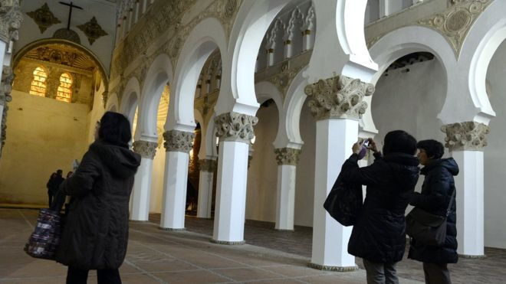
Image caption: The Spanish government calls the expulsion of tens of thousands of Jews in 1492 a "historic mistake"
Spain has granted citizenship to 4,302 people whose Jewish ancestors were expelled five centuries ago during the Inquisition.

A new law allowing dual citizenship for the descendants of those forced out in 1492, known as Sephardic Jews, was passed in June. It came into force on Thursday.
Friday's move, however, follows a government decision to fast-track those who had applied for citizenship under a previous law. The older law had required them to relinquish their other nationality.

Most of the group are from Morocco, Turkey and Venezuela, Spain's Federation of Jewish Communities said.
Justice Minister Rafael Catala said the decision had been made so they would not have to file another application.
Those seeking citizenship under the new law need to have their ancestry checked by Jewish authorities. They must also demonstrate basic knowledge of Spanish, pass a test about Spanish culture and prove a modern connection to Spain.

Who are the Sephardic Jews?
- Jews have lived in Spain since Roman times
- Sephardic comes from the Hebrew word Sepharad, which means Spain
- Originally used to refer to descendants of the Jews from Spain
- They are scattered around the world - in Israel, Turkey, the US, South America, Greece, Bulgaria, France, the UK and elsewhere
- Sephardic Jew is now a wider term, and can refer to Jews of Oriental, Asian and African origin

Tens of thousands of Jews were expelled in 1492 during the Spanish Inquisition, which the government has called a "historic mistake". Those who remained had to convert to Catholicism or risk being burnt at the stake.

The citizenship programme was first announced in 2012.

Muslims Angry Over Spanish Citizenship for Jews
by Soeren Kern
December 21, 2012 at 5:00 am
https://www.gatestoneinstitute.org/3509/spanish-citizenship-jews
- Muslims are now demanding reciprocity, demanding that the Spanish government grant automatic citizenship to millions of descendants of Muslims who were also expelled from Spain in the Middle Ages.
The Spanish government has announced that it will grant automatic citizenship to Jews of Sephardic descent, whose ancestors were expelled from Spain in 1492. The measure has been welcomed by Jewish groups, who say the move is long overdue and that it rights a historic wrong.
But Muslim groups are now clamoring for reciprocity, and are demanding that the Spanish government grant instant citizenship to millions of descendants of Muslims who were also expelled from Spain during the Middle Ages.
The so-called Right of Return for Sephardic Jews (Sepharad means Spain in Hebrew) was announced in Madrid on November 22 by the Spanish Justice Minister, Alberto Ruiz-Gallardón, and the Foreign Minister, José Manuel García-Margallo.
Under existing Spanish law, Sephardic Jews already benefit from a preferential naturalization procedure that allows them to claim Spanish citizenship after having lived in Spain for only two years, a privilege that is also available to citizens of Spain's former colonies in Latin America and elsewhere.
The change means that Sephardic Jews -- wherever they live in the diaspora -- will have to present an accreditation from the Spanish Federation of Jewish Communities (FCJE), a Jewish umbrella group, confirming their ancestry to claim a Spanish passport.
Spain's offer applies only to those who identify themselves as Jewish. It does not apply to Sephardic Anousim (anousim in Hebrew means "coerced"), the descendants of Jews who were compelled by the Spanish Inquisition to convert to Roman Catholicism (they are sometimes also called crypto-Jews or Marranos). Secular anousim must seek religious training from the FCJE and undergo formal conversion to Judaism before they can obtain Spanish citizenship.
The Spanish government has not said how many Jews it expects will apply for citizenship (a total of 698 Sephardic Jews obtained Spanish citizenship during the period 2006-2010). There are an estimated three million Sephardic Jews around the world today. Most live in Israel, the United States, Belgium, Greece, France and Turkey, but there are also sizeable communities in Latin America, especially in Argentina, Brazil, Chile, Mexico and Venezuela.
No more than 45,000 Jews currently live in Spain -- out of a total Spanish population of 47 million -- which is only a fraction of the number of Jews who lived in the country before 1492, when Jews were forced to convert to Roman Catholicism or go into exile.
The Edict of Expulsion, issued on March 31, 1492 by the Catholic Monarchs of Spain (Isabella I of Castile and Ferdinand II of Aragon), and also known as the Alhambra Decree, ordered Jews to leave the Kingdoms of Castile and Aragon, and their territories and possessions, by July 31 of that same year.
Up to 800,000 Jews are believed to have left Spain as a result of the decree. Another 50,000 chose to avoid expulsion by converting to Roman Catholicism.
Spain first began granting citizenship to Sephardic Jews -- on an individual basis, not en masse -- in 1988, when the government of Felipe González modified the Spanish Civil Code. The concessions were halted in 2009 by the Socialist government of José Luis Rodríguez Zapatero, but the procedure has now been revived and amended by the conservative government of Mariano Rajoy.
Reacting to the Rajoy government's pledge to expedite the naturalization process for Sephardic Jews, Isaac Querub, the president of the FCJE, declared that November 22, 2012 would "pass into history as a day of clear blue sky and intense luminosity."
For his part, Foreign Minister García-Margallo emphasized the historic links of the Jewish people with Spain. At a ceremony at the Centro Sefarad-Israel in Madrid, he said: "Our relations have never been forgotten and have intensified the more tolerant and democratic Spain has become."
But Spanish political commentators have been speculating about both the reason and the timing behind the government's move.
Just one week after announcing the Right of Return for Sephardic Jews, Spain voted in favor of upgrading the status of the Palestinian Authority at the United Nations. The November 29 vote was a major blow to Israel; some commentators have speculated that Spanish government announced the citizenship measure as a "gesture" to minimize the impact on bilateral relations.
Others say the Spanish government is seeking to attract Jews as a way help remedy the country's severe economic problems. Just days before welcoming Sephardic Jews back to Spain, the government announced on November 19 that it would offer residency permits (the equivalent of a US green card) to foreigners who buy houses priced at more than 160,000 euros ($200,000) as part of its efforts to revive a collapsed real estate market and divest itself of hundreds of thousands of unsold homes.
Meanwhile, Muslims are now demanding that the Spanish government grant automatic citizenship to millions of descendants of Muslims who were expelled from Spain in the seventeenth century.
Much of the Iberian Peninsula was occupied by Muslim conquerors known as the Moors from 711 until 1492, when the Moorish Kingdom of Granada surrendered to Ferdinand and Isabella. But the final Muslim expulsion from Granada, known in Arabic as Al-Andalus, did not take place until over a century later, beginning in 1609, when King Philip III decreed the Expulsion of the Moriscos.
The Moriscos were the descendants of the Muslim population that converted to Roman Catholicism under threat of exile from Ferdinand and Isabella in 1502. From 1609 through 1614, the Spanish government systematically forced an estimated 350,000 Moriscos to leave Spain for Muslim North Africa.
Today there are an estimated 5 million descendants of the Moriscos living in Morocco alone; there are millions more living in Algeria, Egypt, Libya, Mauritania, Tunisia and Turkey.
In a December 3 essay published by the Morocco-based newspaper Correo Diplomático, the Moroccan journalist Ahmed Bensalh Es-salhi wrote that the "decision to grant Spanish citizenship to the grandchildren of the Hebrews in Spain in the fifteenth and sixteenth centuries, while ignoring the Moriscos, the grandsons of the Muslims, is without doubt, flagrant segregation and unquestionable discrimination, as both communities suffered equally in Spain at that time. The decision could also be considered by the international community to be an historic act of absolute immorality and injustice…This decision is absolutely disgraceful and dishonorable."
Bensalh then went on to threaten Spain: "Is Spain aware of what might be assumed when it makes peace with some and not with others? Is Spain aware of what this decision could cost? Has Spain considered that it could jeopardize the massive investments that Muslims have made on its territory? Does Spain have alternatives to the foreign investment from Muslims if they ever decide to move that capital to other destinations due to the discrimination against Muslims?"
Bensalh's article is the latest salvo in an escalating battle being waged by Muslim historians and academics who are demanding that Spain treat Moriscos the same way it treats Sephardic Jews.
Jamal Bin Ammar al-Ahmar, an "Andalus-Algerian" university professor at the Ferhat Abbas University in Sétif in northeastern Algeria, has been engaged in a four-year campaign to persuade Spanish King Juan Carlos to identify and condemn those who expelled the Muslims from Al-Andalus in the fifteenth century. Al-Ahmar is also demanding that millions of Moriscos expelled from Spain be allowed to return there.
In a letter addressed to Juan Carlos, Al-Ahmar calls for a "full legal and historical investigation of the war crimes that were perpetrated on the Muslim population of Andalusia by the French, English, European and papal crusaders, whose victims were our poor miserable people, after the collapse of Islamic rule in Andalusia."
The letter speaks of "the injustice inflicted on the Muslim population of Andalusia who are still suffering in the diaspora in exile since 1492."
Al-Ahmar wants the Spanish monarch to apologize "on behalf of his ancestors" and to assume "responsibility for the consequences" that this would entail. He says it is necessary "to identify criminals, to convict retroactively, while at the same time to identify and compensate victims for their calamities and restore their titles." This process would culminate with "a decree that allows immigrants to return to their homes in Andalusia, and grant them full citizenship rights and restoration of all their properties."
Soeren Kern is a Senior Fellow at the New York-based Gatestone Institute. He is also Senior Fellow for European Politics at the Madrid-based Grupo de Estudios Estratégicos / Strategic Studies Group. Follow him on Facebook.

