Exercise: Constructing an Argument

Name: Hour: Topic:

Divide your notebook paper as shown. Construct your argument using the instructions below.
- Write in full sentences.
- Do not write outside these boxes or on the other side of the paper.
- Cite at least three sources from “Room for Debate” overall, using author name.
- You will be peer evaluated according to the criteria on the other side of this page.
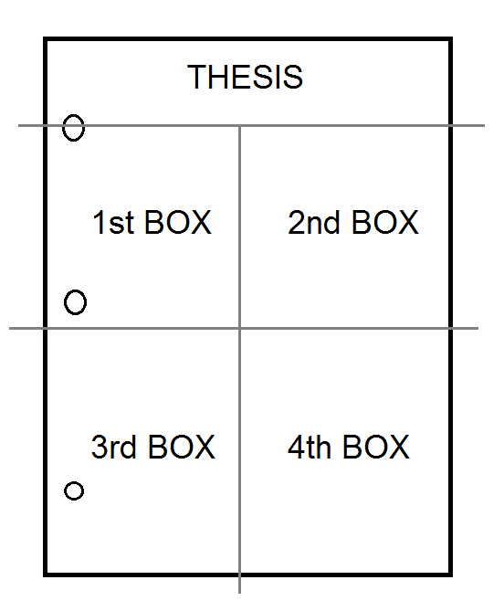
Thesis Statement (1-2 sentences)
A thesis statement is a one or two sentence summary of your argument.
TIP: Do not begin with “I think,” “I believe,” etc., for two reasons. First, as the writer, of course you are writing what you think or believe. Your reader knows this. Second, as this is an academic piece, do not write in the first person (don’t use “I,” “we,” “us,” etc.).

First Box: Background (3 sentences)
Provide historical background or “set-up” for your argument. What does the reader need to think about or know before reading in order to understand your argument?

Second Box: Argument (3 sentences)
Introduce your argument in full sentences and explain what you think. (Remember: don’t say “I think” or “I believe”—just state your claims!)

Third Box: Address Counterarguments (3 sentences)
Surely, not everyone in the world agrees with your thoughts. Explain one or more arguments someone would perhaps use against you and how you would respond.

Fourth Box: Significance (3 sentences)
Why should anyone care about this issue? What is at stake? What stands to be lost and/or gained if your viewpoint prevails? Explain your reasoning.

You are graded on quality of completion of the activity (18 points: 2 for thesis and 4 per box) and quality of feedback you provide to a peer (5 points).
Peer Evaluation Peer evaluator’s name:

Circle one descriptor for your peer’s work for each statement.

Thesis box: The thesis statement makes sense as an argument.

Not at all Not really Kind of Absolutely, yes

First box: The background information tells me what I need to know to understand the argument.

Not at all, I was lost Not really Kind of Absolutely, I was prepared

Second box: The argument is well-explained and makes sense (no matter if I agree with it or not).

Not at all Not really Kind of Absolutely, yes

Third box: The counter-arguments are real, significant, and are fully addressed. (Your peer doesn’t need to have fully solved every counter-argument; they just need to acknowledge and attempt to solve counterarguments.)

Not at all Not really Kind of Absolutely, yes

Fourth box: This issue’s significance is fully explained and makes me care.

Nope, my heart is ice Not really Kind of Absolutely, I feel things

Explain at least one way your partner can make any part of this argument better. How can they improve? Do you have a counter-argument or point to add? Answer in 2-3 full sentences.

