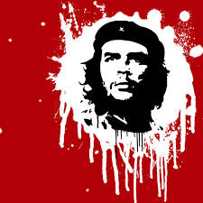***South American Travels*** (Ch. 29) Name:

**Brazil**

*What problems prompted the Brazilian military to take control in 1964?*

*Brazil practiced* ***laissez-faire economics*** *during the mid-1900s. What are two negative effects?*

*How did democracy return to Brazil?*

**Mexico**

*What is the official political party of the Mexican Revolution?*

*Students began to protest against the one-party system at the end of the 1960s. What are two changes that followed these protests?*

*What is privatization, and why did the Mexican government adopt the policy of privatization?*

**Central America**

*What seven nations comprise Central America?*

*What goal did the U.S. have for supporting harsh regimes in this region?*

*Why was a civil war fought in El Salvador?*

*The Sandinistas and the Contras fought over Nicaragua. Why did the U.S. support the Contras?*

*What are two ways the U.S. influenced Panama?*

**Cuba**

*Who did Fidel Castro overthrow, using guerilla warfare?*

*What happened in Oct. 1960 and Jan. 3, 1961?*

*Why did Castro attempt to export his revolution to other South American nations?*

*What are two successes of Castro’s regime?*

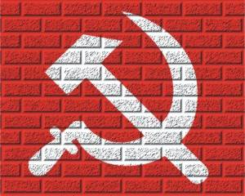

**Argentina**

*Juan Peron was a member of the military group that seized power in Argentina during WWII. How did Peron and his wife, Eva, seek popular support?*

*How did the working class have Peron’s back?*

*Why did Great Britain and Argentina go to war around the time the Nicaraguan Contras were being funded by America?*

*What peaceful transition happened in 1989?*

**Peru**

*General Alvarado formed peasant cooperatives for what reason?*

*The military took power from Alvarado and then a few years later returned control to a civilian government. Why return control?*

*To what ideology did the Shining Path adhere?*

*Why did Pres. Fujimori suspend the constitution/Congress and become a dictator?*

**Write two key takeaways or questions from the Crash Course video.**

**Chile**

*What Marxist steps did Pres. Allende take?*

*Why did Americans care?*

*Gen. Pinochet led the overthrow of Allende. Describe Pinochet’s rule.*

**Colombia**

*Why were 200,000+ peasants killed here by the time of student protests in Mexico and the Cuban Missile Crisis?*

*Peasants originally turned to producing cocaine as a way to escape poverty. What methods did cartels use to ensure economic success?*

*What two economic factors were hampering Colombia at the time this textbook was written?*