What is the Spanish Inquisition? Name:
In your groups, you’ll complete a large-scale Frayer Model to explore your thoughts and demonstrate comprehension.
Procedure:
- Divide your sources between your group mates. Each person should have ~2 sources to explore that fit their strengths.
- Read your sources and take a minimum of ten high-quality bullet point notes in your notebooks. Make sure to note information to fit the categories seen below (graphic below is just for reference—don’t fill it out!).
- At Ms. Boyd’s signal, you will each share out with your group what your sources say about the Spanish Inquisition.
- Decide as a group what to include on your large-scale Frayer Model. If your sources disagree, you need to decide which source is more trustworthy, and be prepared to defend your decision if asked!
- At the end of this activity, you’ll complete the reflection on the reverse of this paper.

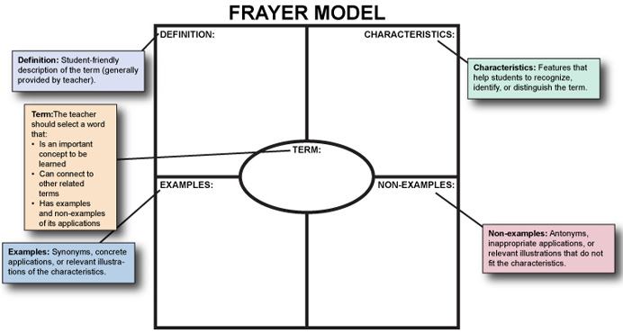

Self-Evaluation

- What skills did you use today?
- On a scale of 0 (low) to 100 (high), how high-quality are your bullet points? Are they diverse, numerous, and authentic? (Are you not just writing so that Ms. Boyd sees you have words on the paper?)

- What grade would you give your group’s Frayer Model? Why?

- Which of your group mates would you nominate as Most Helpful? Why?

