Toward the Modern Consciousness

Camille Pissarro, Impressionism (quote at beginning of class)

A New Physics
- Prior to 1914, science was a way to view the world accurately, to measure it. Europeans held a mechanical view of the universe.
- Marie Curie: discovered radioactive elements that gave off energy from within themselves. Established that atoms weren’t solid “building blocks,” but “small, active worlds.”
- Albert Einstein: new view of the universe. Theory of relativity: space and time are not absolute, but are relative to the observer.
  - Time and space are dependent upon human experience
  - Matter is just another form of energy (E=MC²)
    - Led to Atomic Age
  - This new “relative” universe is without certainty (different from Newton’s mechanical, predictable universe)

Psychoanalysis
- Sigmund Freud questioned the human mind
- Added to uncertainties of the world
- 1900: The Interpretation of Dreams
- Past experiences and our unconscious feelings affected human behavior
- Used psychoanalysis to explore deep or repressed (hidden) memories, to figure out behavior
- By 1920s, psychoanalysis was major profession

Social Darwinism and Racism
- Applied biological theory of evolution to human society; social progress comes as the rich and the strong advance while the poor and weak die. The rich and strong succeed because they are better.
- Combined nationalism and racism
- Germany: some argue that Germans are purest “Aryan race,” and are being fought by the Jews.

Anti-Semitism and Zionism
- A.S.: hostility and discrimination toward Jews
  - For hundreds of years, Jews were discriminated against
  - Dreyfus Affair: Jewish captain unfairly blamed for a crime; eventually pardoned, with public support
- Germany and Austria-Hungary: politicians used A.S. to win votes
- Eastern Europe and Russia: Jews forced to live in certain areas but barred from owning land; persecution and pogroms (organized massacres) happen
- Jews escape persecution: move to America and Palestine, among other places
  - P.: land of ancient Israel; land of their dreams. Zionism = Jewish nationalism/desire for a Jewish homeland (not realized til after WWII)

Culture of Modernity
- Modernism: rebellion against traditional styles in writing and arts
- Literature
  - 19th cent.: naturalism and realism; wrote of social problems (role of women, alcoholism, slums)
  - 20th cent: symbolism; poetry and influence of Freud
    - objective knowledge is impossible
    - world is only collection of symbols that reflect the human mind
- Painting
  - Art changed to reflect different worldviews in 20th cent.
  - Moved away from realism
  - Impressionism
    - Monet and Renoir
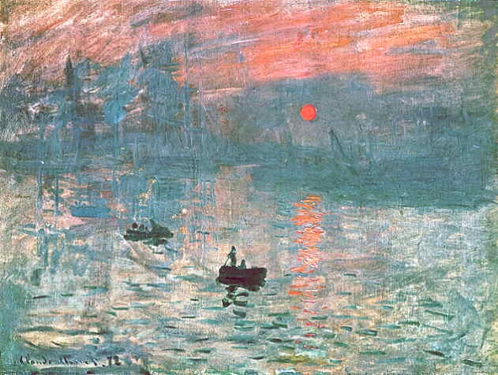
    - Natural themes
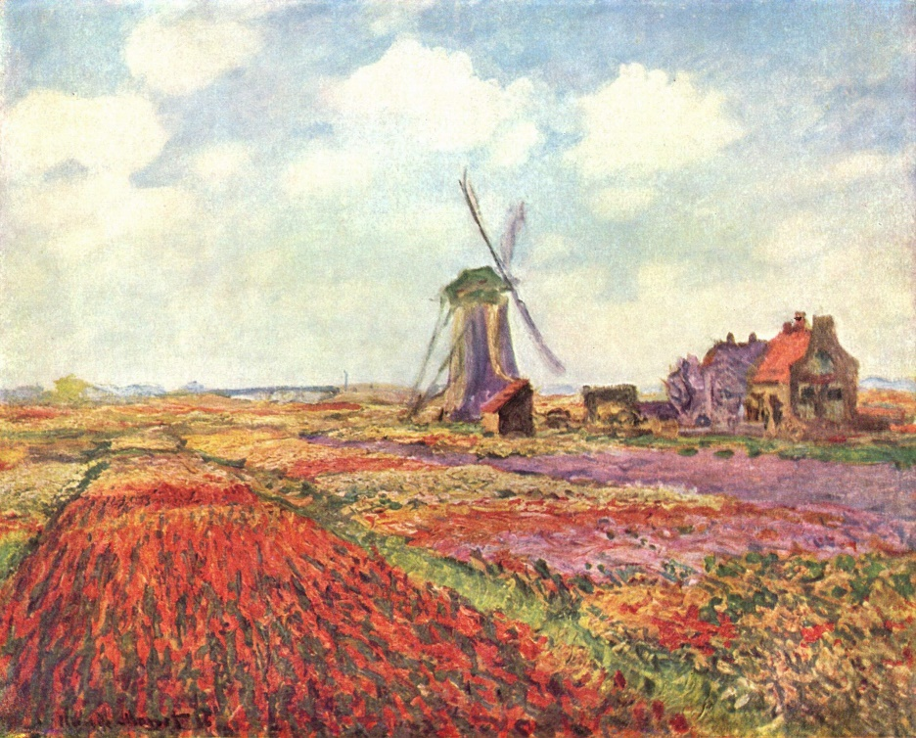

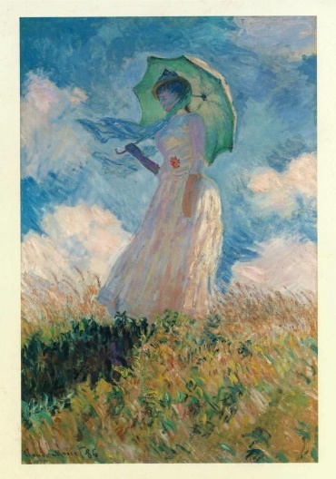

  - Post-impressionism
    - Van Gogh
    - Art is spiritual, full of feeling
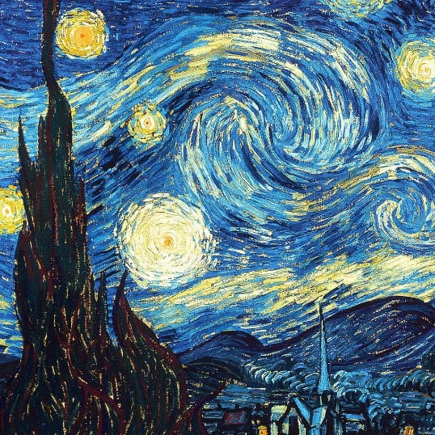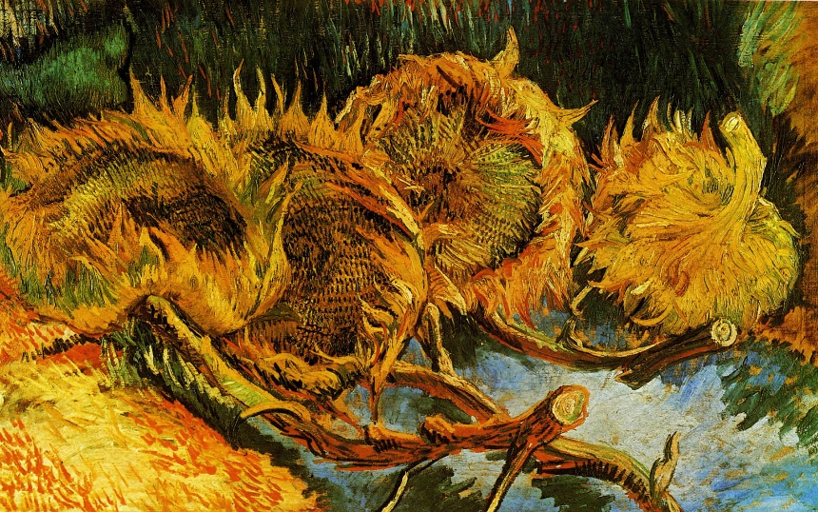

  - 20th century: photos can represent reality; art should create reality for viewer
    - Picasso, cubism, influenced by relativity
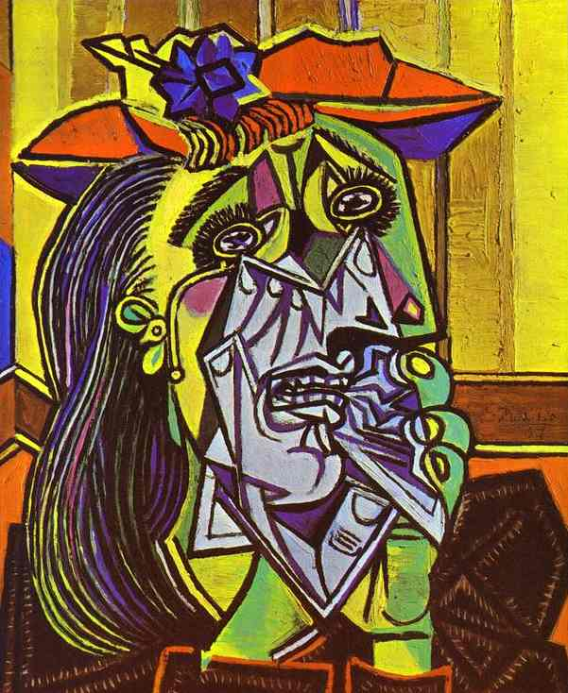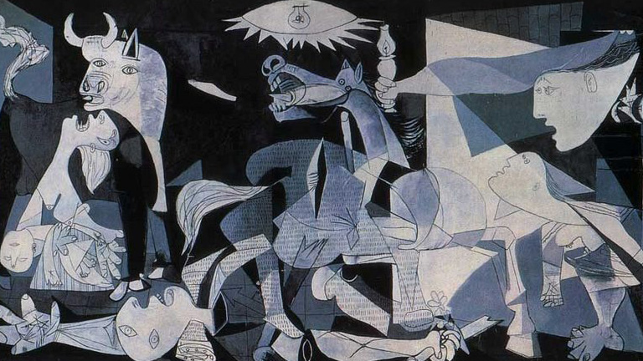
“A painting is not thought out in advance. While it is being done, it changes as one’s thoughts change. And when it’s finished, it goes on changing, according to the state of mind of whoever is looking at it.”

    - Kandinsky, abstract painting speaks directly to the soul
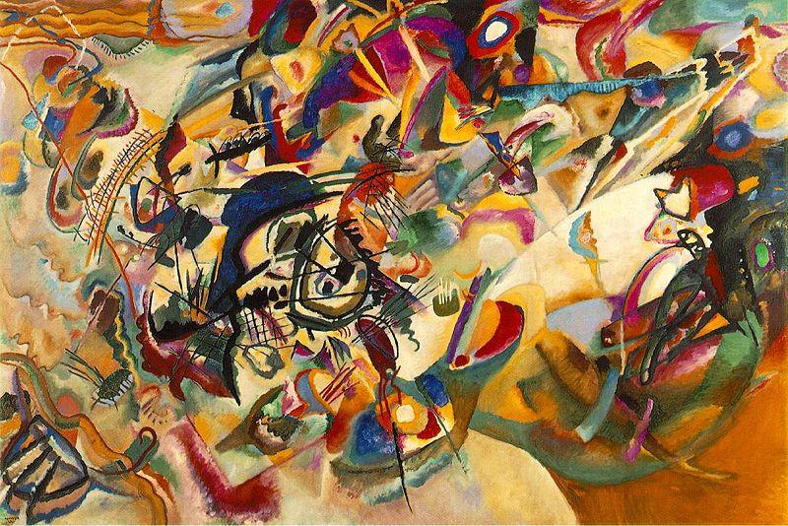
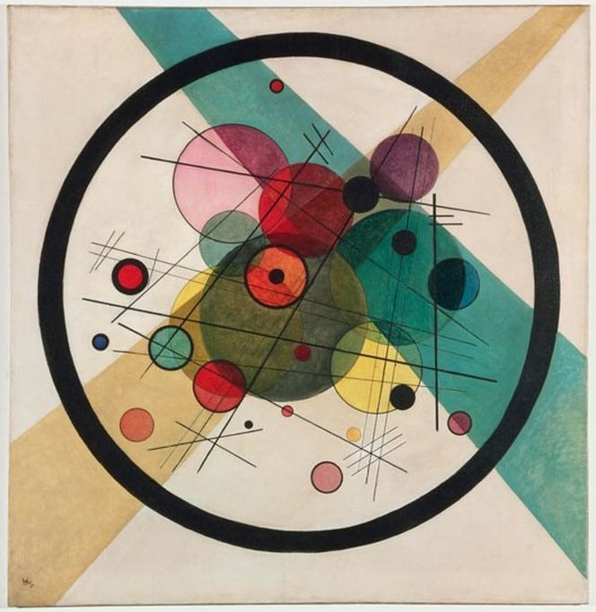

Architecture
  - Modernism in art led to functionalism in arch. (nothing fancy, just functional)
    - Frank Lloyd Wright, Chicago School
    - https://www.youtube.com/watch?v=HuZ0x5Qkgzg
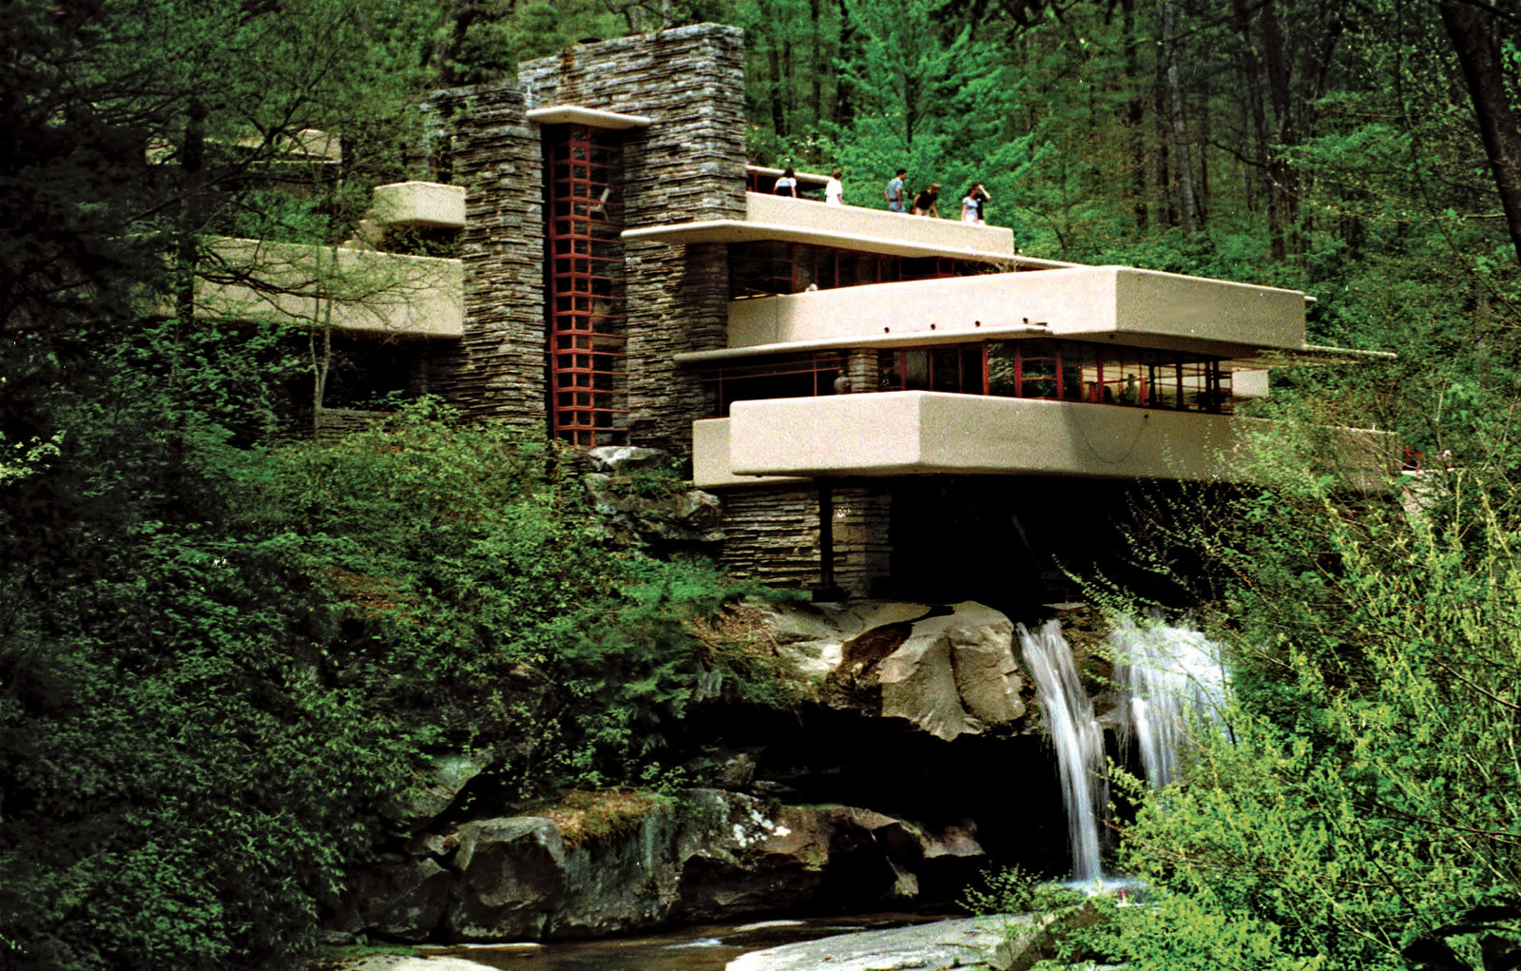

- Music
  - Stravinsky, expressionist themes
    - The Rite of Spring (1913) almost caused a riot because he broke so many “rules” of music and ballet https://www.youtube.com/watch?v=4MfWQt0rrQ4
    - If time: https://www.youtube.com/watch?v=jF1OQkHybEQ

